

**ASSIGNMENT**

**TECHNOLOGY PARK MALAYSIA**

**CT106-3-2-SNA**

**SYSTEM AND NETWORK ADMINISTRATION  
APU2F2502**

**HAND OUT DATE: WEEK 2 MARCH**

**HAND IN DATE: WEEK 10 MAY**

**WEIGHTAGE: 30%**

**TITLE: Individual SNA Network Administration Project**

**NAME: Lee Yi Chern**

**TP NO: TP081340**

Table of Content

1.0 Introduction 3

2.0 Basic Settings 4

3.0 Postfix 9

3.1 Installation of Postfix 9

3.2 Configuration of Postfix 11

4.0 Dovecot 19

4.1 Installation of Dovecot 19

4.2 Configuration of Dovecot 21

5.0 SSL 26

6.0 Mozilla Thunderbird 33

7.0 Test Email 36

8.0 Troubleshooting 40

9.0 Certificates of Attendance 46

10.0 Conclusion 47

11.0 References 48

# 1.0 Introduction

In this assignment, we configured a Linux mail server that is simple yet functional. The objective is to use open-source tools to make email sending and receiving possible. Postfix, Dovecot, SSL/TLS encryption, and the Mozilla Thunderbird email client are the primary components that we configure. With this configuration, we can use self-signed certificates to mimic a safe, end-to-end email environment inside a local network.

Every tool serves a distinct function: Postfix, which serves as a Mail Transfer Agent (MTA), handles the email transmission across servers. Dovecot controls local mail storage and user access, in addition to acting as the Mail Delivery Agent (MDA) and server for IMAP/POP3. To safeguard sensitive information, SSL/TLS offers clients and servers encrypted communication routes. Thunderbird serves as the mail client that users see, securely connecting to send and receive messages.

The entire email sending and receiving process is managed by these tools working together. Thunderbird authenticates the user and creates a connection to the Postfix server via the submission port (SMTP) when a user sends an email. After processing the message, Postfix transmits it to the mailbox of the receiver. This mailbox is maintained by Dovecot, which also keeps the emails in the proper place. Thunderbird uses IMAP (or POP3) to connect to Dovecot to access and retrieve the new message when the user opens their inbox. SSL/TLS makes sure that all client-server communication is encrypted and shielded from unwanted access at every stage of the procedure.

To sum up, this project shows how to integrate several services to create a private mail server. It offers a practical grasp of the inner workings of email systems, focusing on both functionality and fundamental security procedures in a supervised setting.

# 2.0 Basic Settings

Before jumping into the installation and configuration, we need to ensure that our system is properly set up and up to date.

Step 1: Check OS and Version

* cat /etc/os-release
* uname -r

Rocky Server:

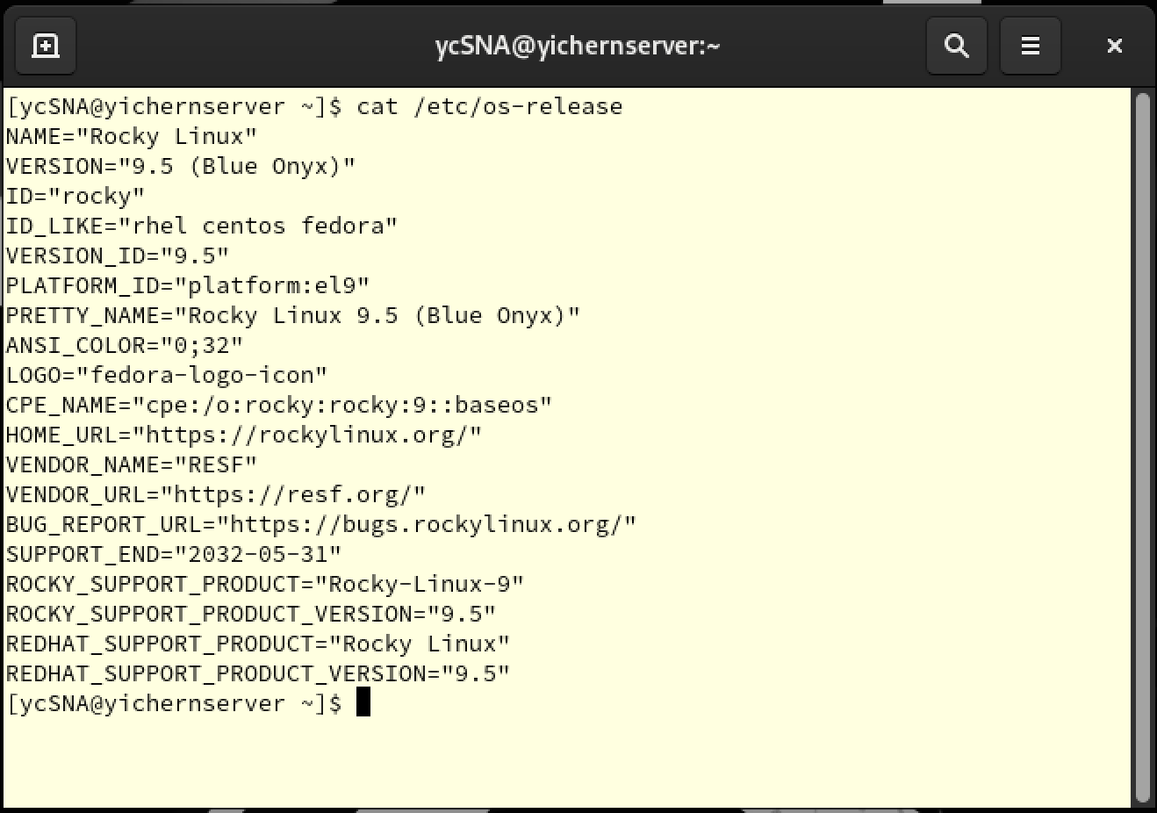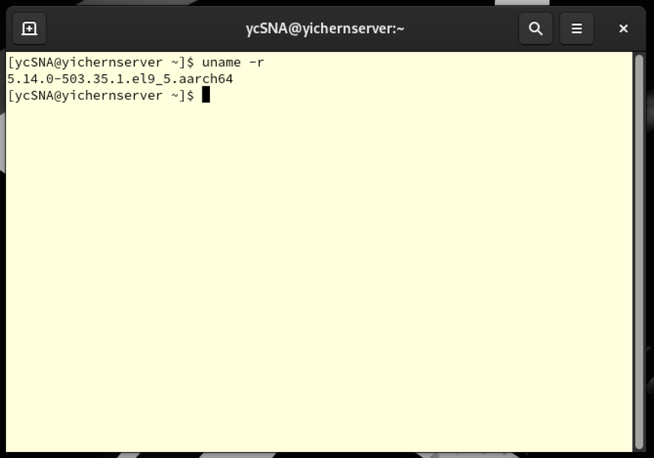

Ubuntu Client:

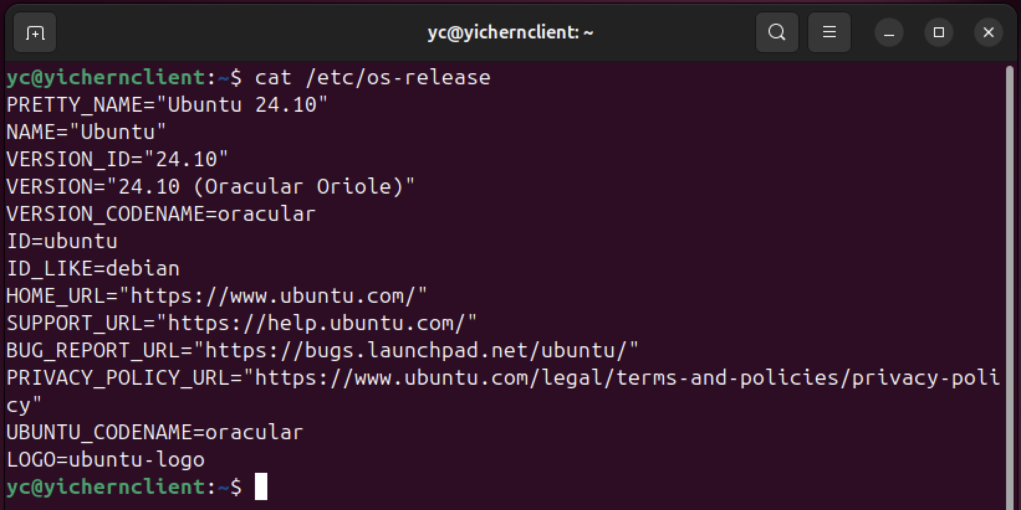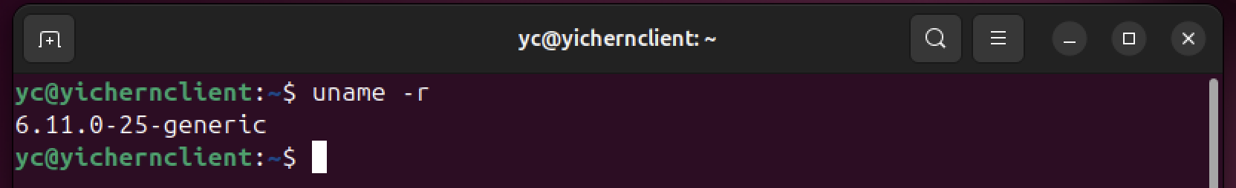

Step 2: Check Network Configuration

* ip a

Rocky Server:

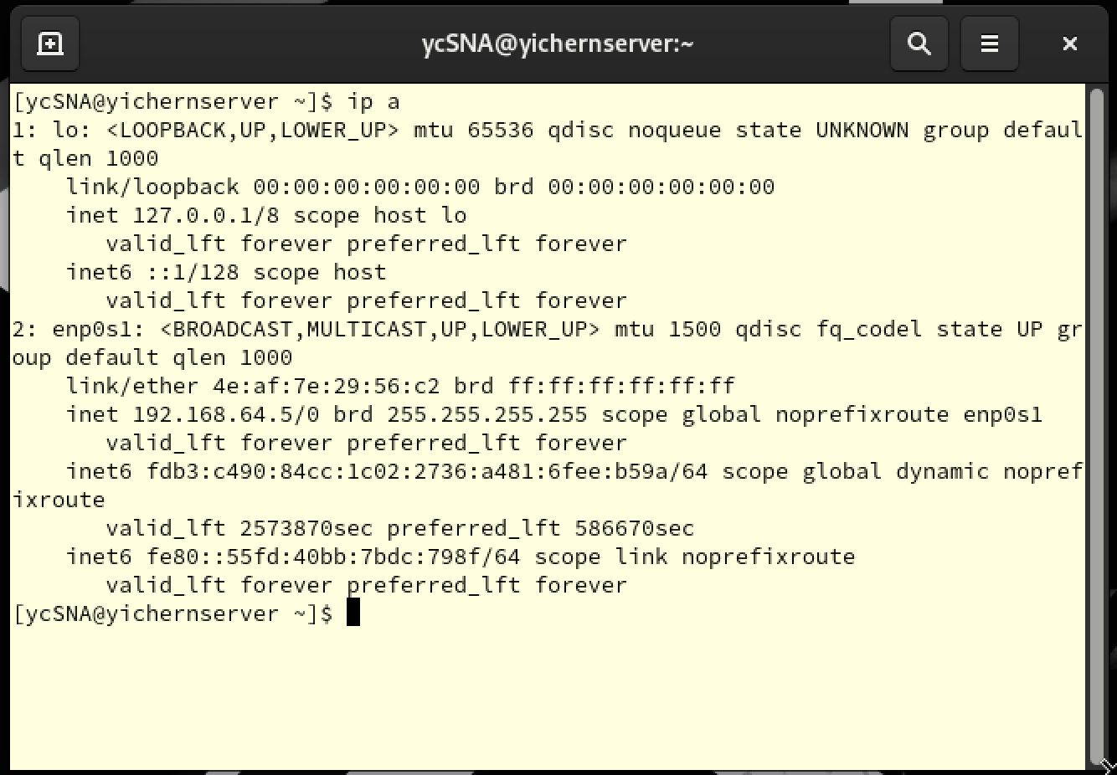

Ubuntu Client:

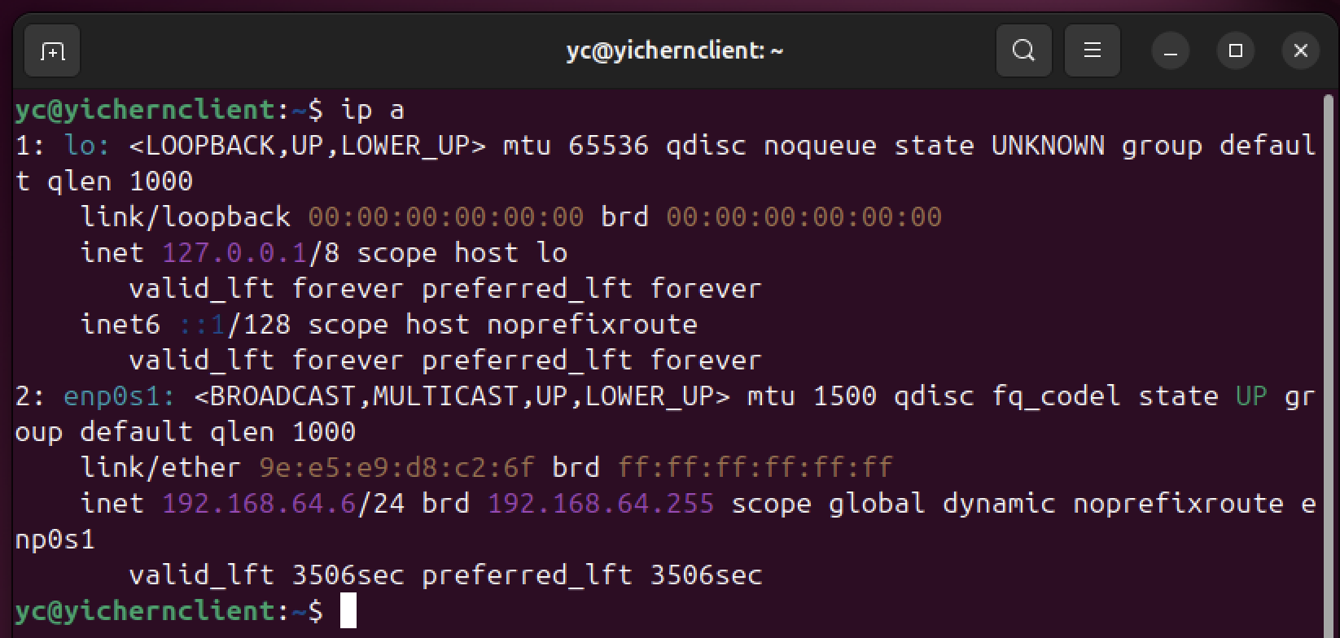

Step 3: Check Hostname and FQDN

* cat /etc/hostname
* cat /etc/hosts

Rocky Server:

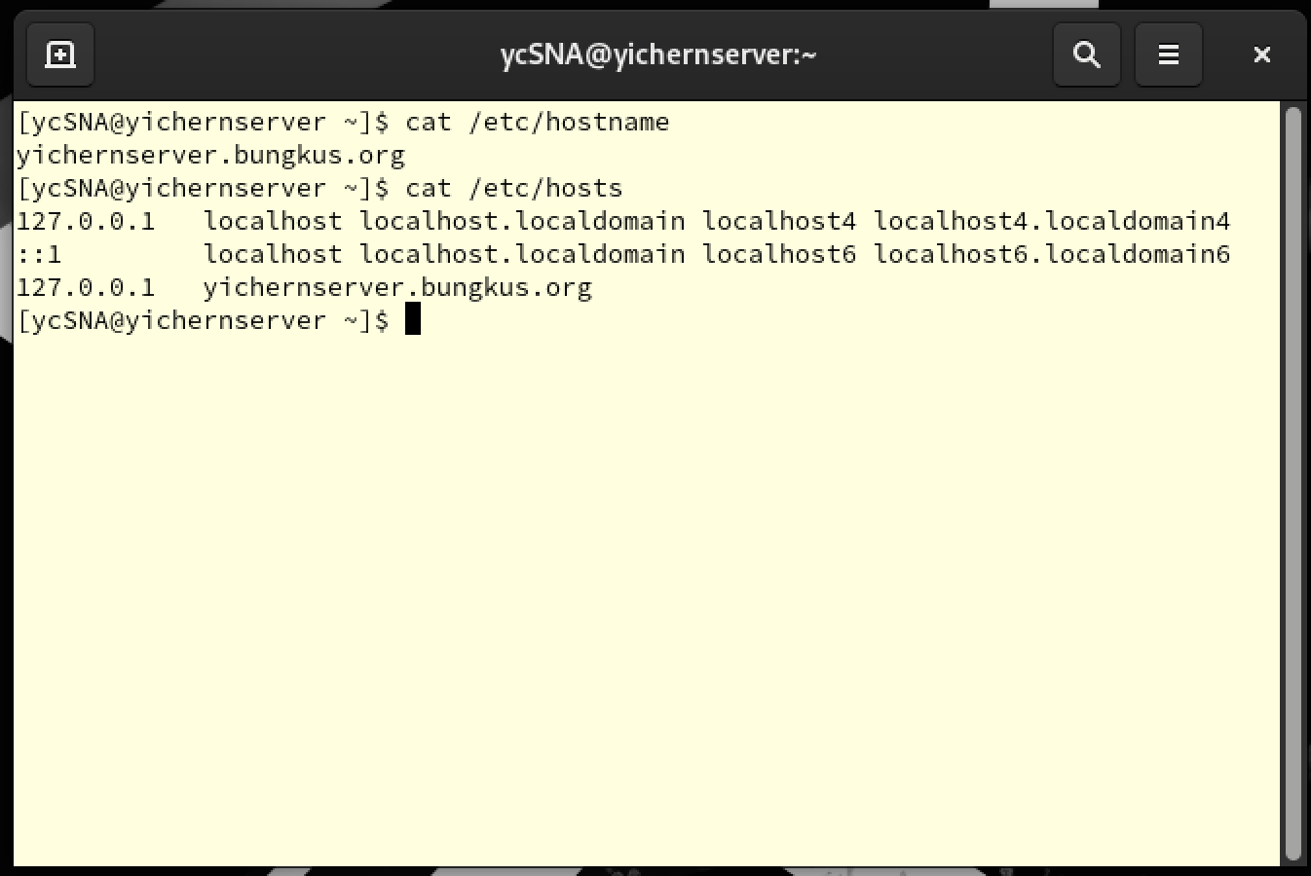

Ubuntu Client:

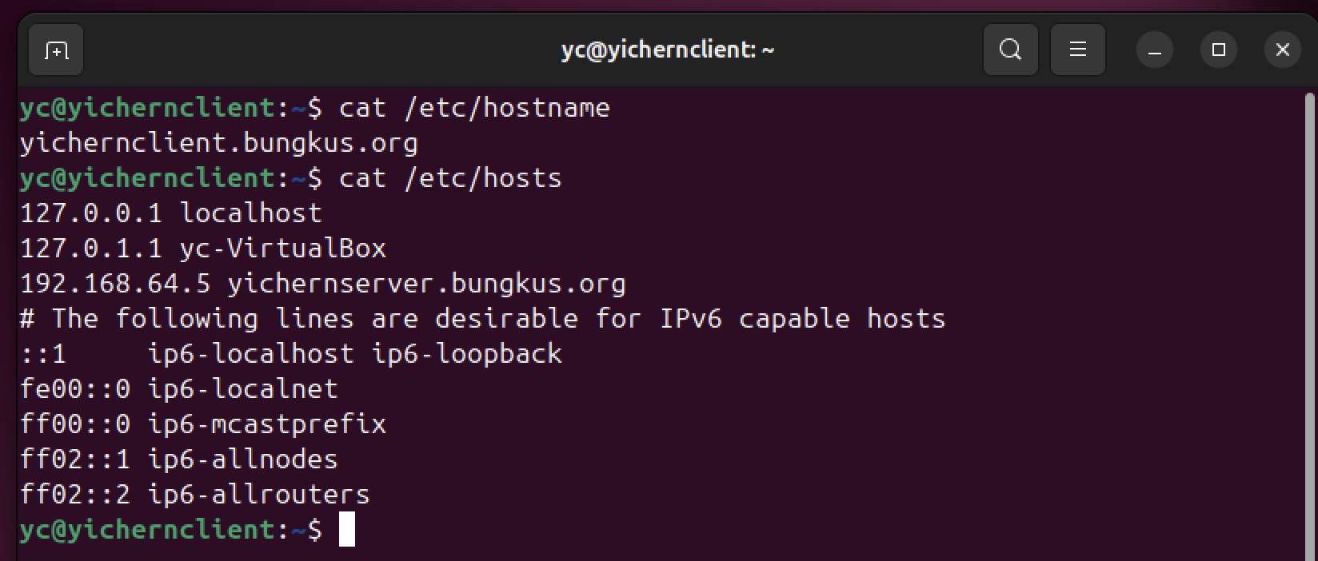

Step 4: Update Our System

* sudo dnf update (Rocky)
* sudo apt update (Ubuntu)

Rocky Server:

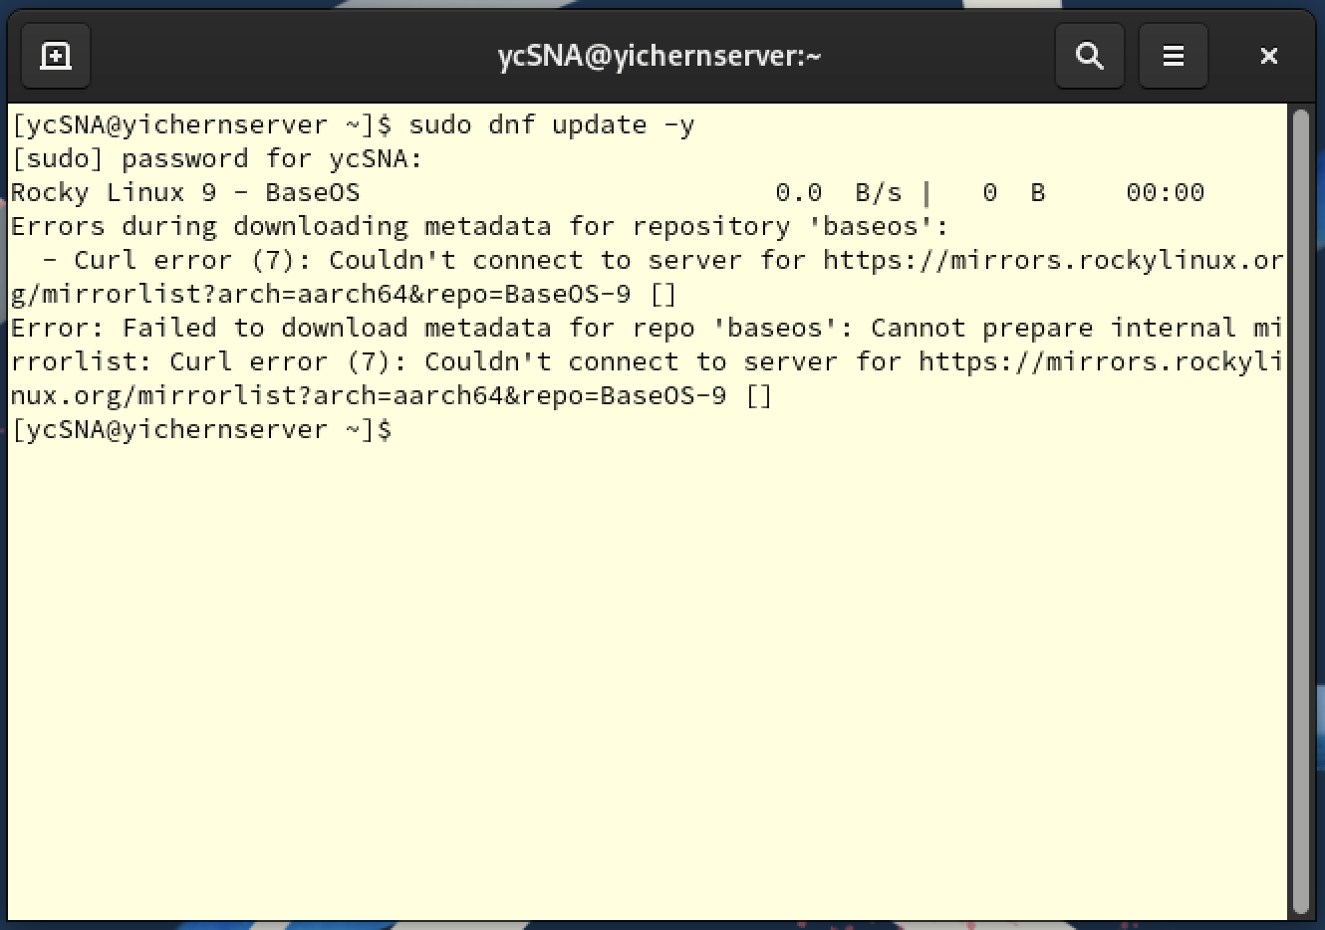

Ubuntu Client:

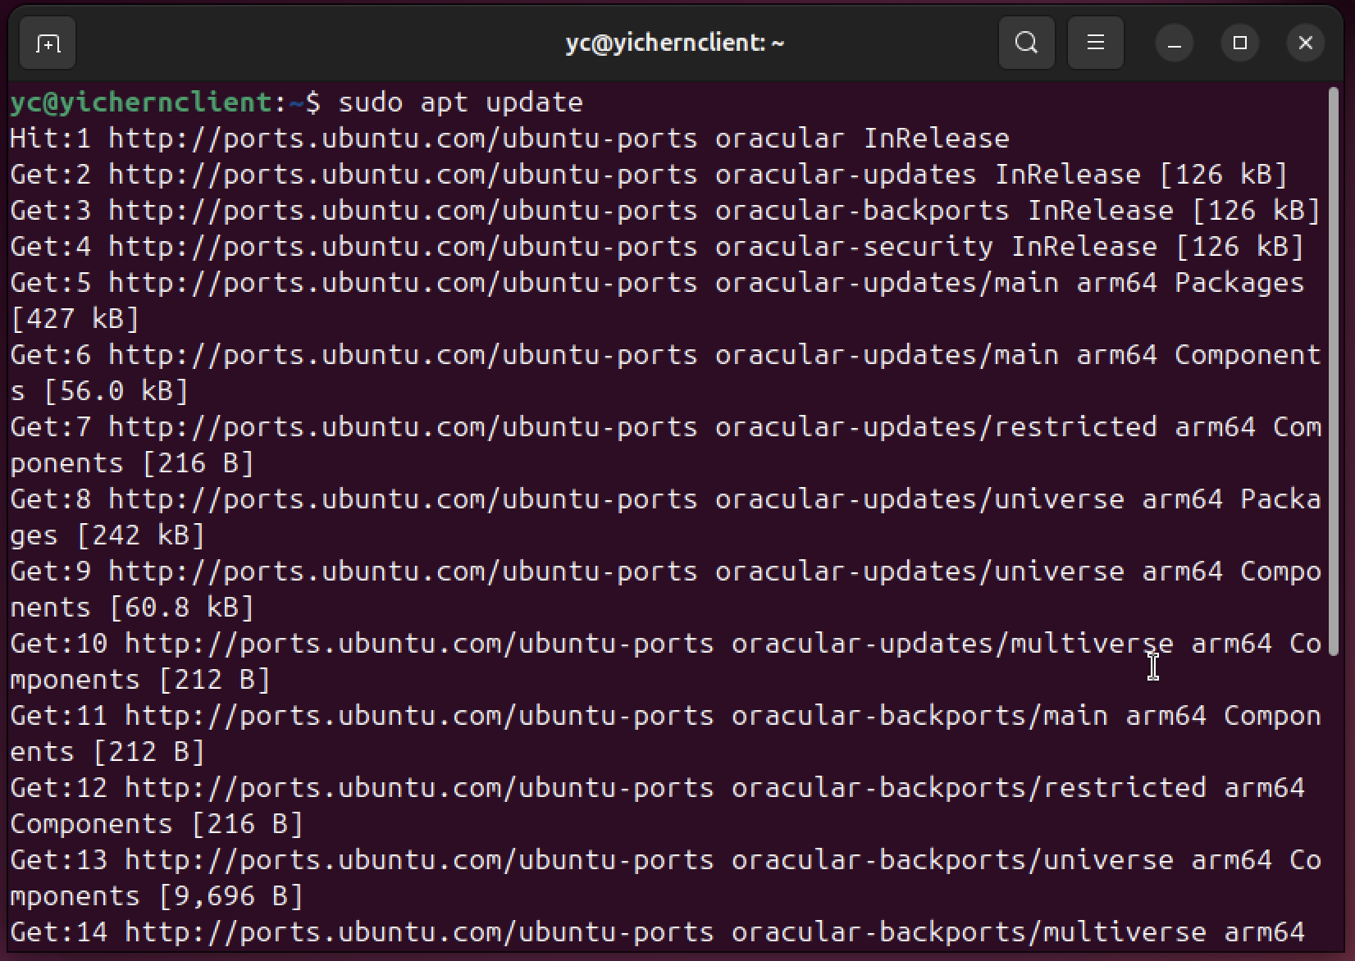

# 3.0 Postfix

Postfix is a Mail Transfer Agent (MTA) which handle the sending, receiving and routing emails on Linux Server. It acts as the central mail handler, when email message been sent by either local user or remote clients (example Thunderbird), the mail will be accepted by Postfix. Then, Postfix will place the queue and determine where should be delivered using SMTP protocol. It is widely be used because of its security, speed and ease of configuration.

In our assignment, we are going to install Postfix and configure it to securely accept emails from client server over port 587, support encrypted connection using SSL/TLS, and deliver messages to local user mailbox.

## 3.1 Installation of Postfix

Step 1: Install Postfix

* sudo dnf install postfix -y

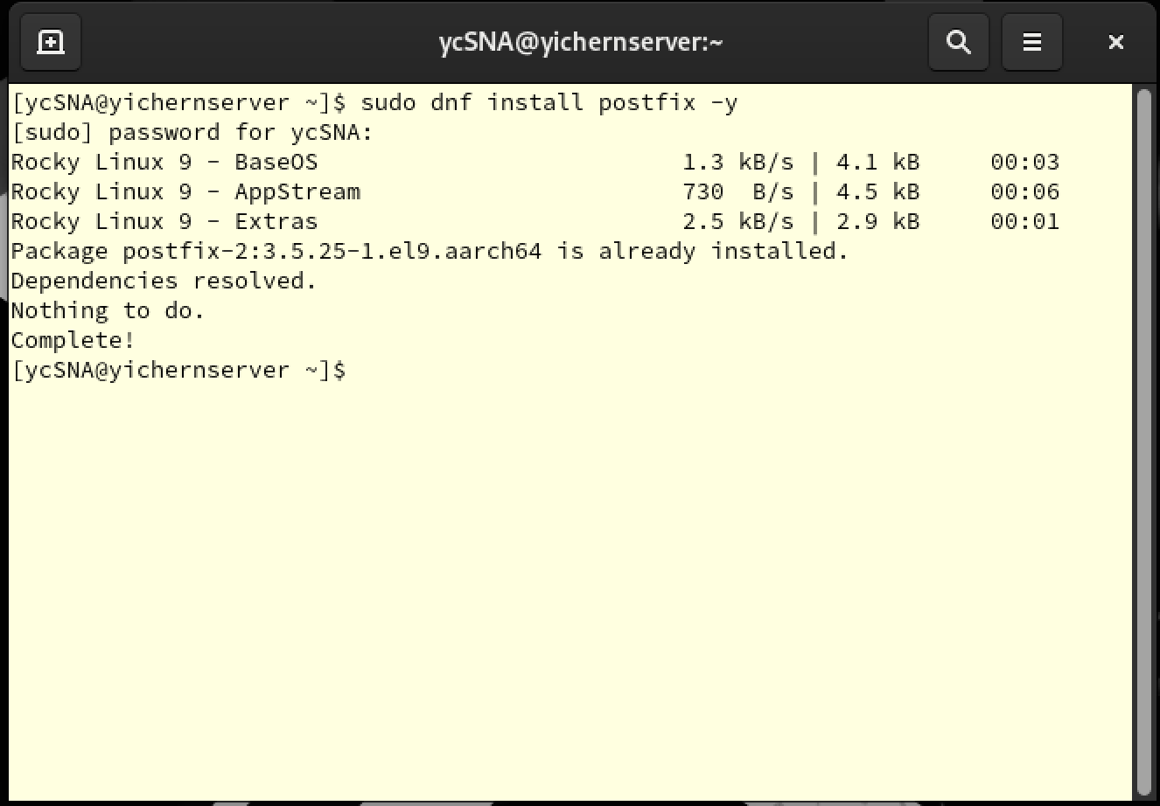

Step 2: Enable and start Postfix

* sudo systemctl enable postfix
* sudo systemctl start postfix
* sudo systemctl status postfix

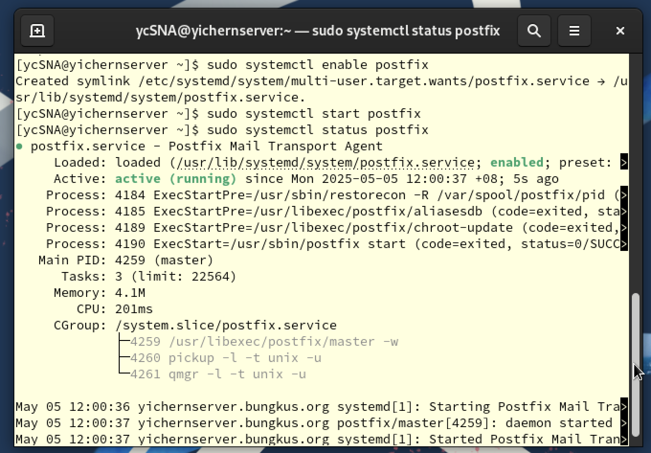

Explanation

* sudo systemctl enable postfix

Sets Postfix start automatically every time when system boots.

* sudo systemctl start postfix

Immediately starts Postfix right now

* sudo systemctl status postfix

Display the current status of the Postfix (make sure it shows **enabled** and **running**)

## 3.2 Configuration of Postfix

Step 1: Enter Postfix main config file

* sudo nano /etc/postfix/main.cf



Step 2: Config the Domain Settings

* In this part, we need to make sure our hostname, domain and origin match our system FQDN, which is yichernserver.bungkus.org

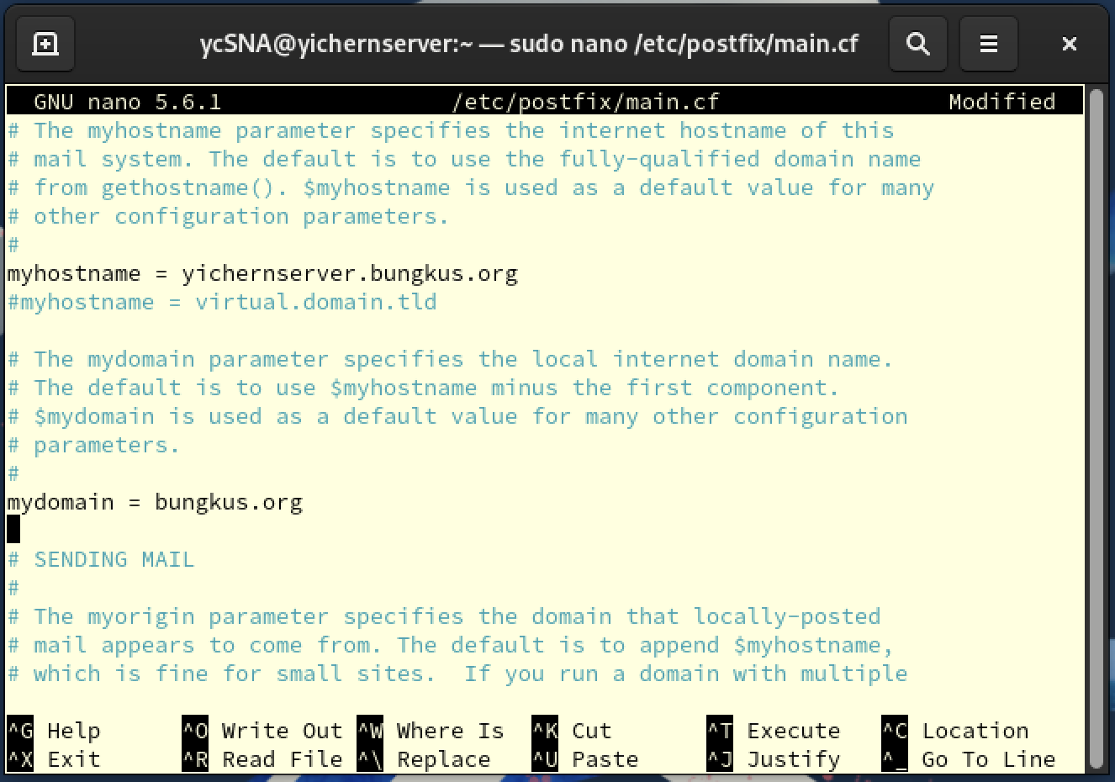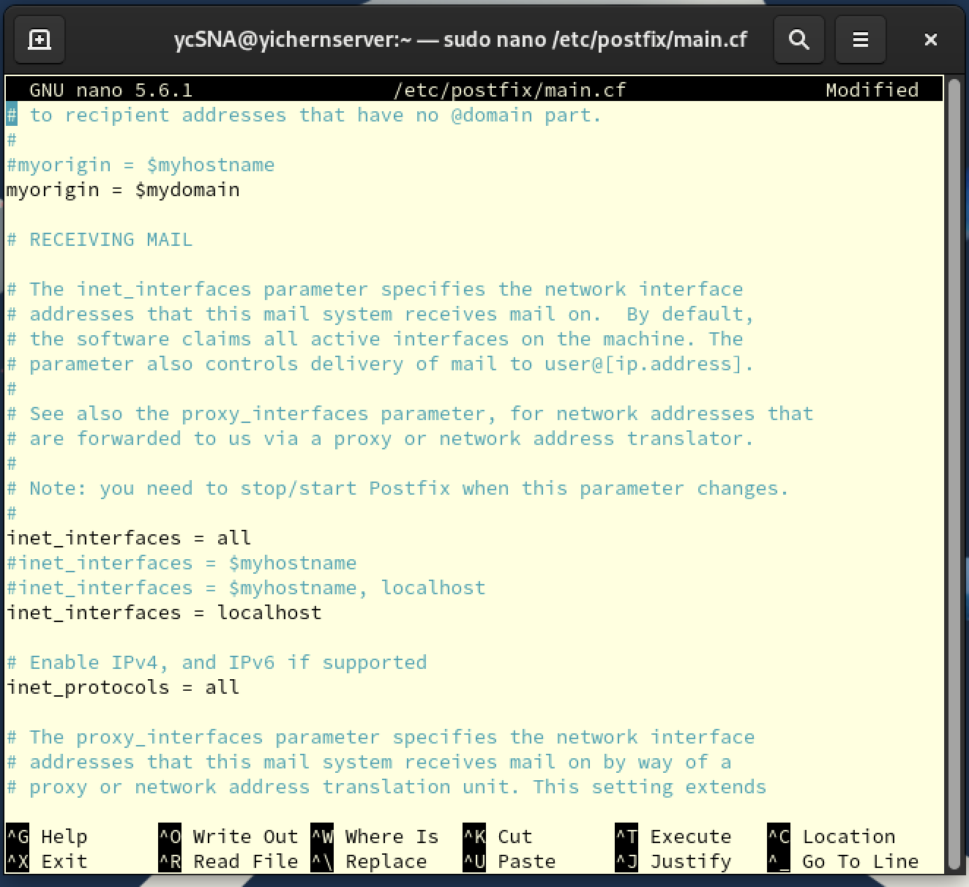

Explanation

While sending emails, Postfix needs to know who it is and where it is to send. In here, we let Postfix know the hostname, domain and origin to build correct sender address (like [user@bungkus.org](mailto:user@bungkus.org)) and identify itself to other mail servers. If the values don’t match, email delivery might fail or get marked as spam.

Step 3: Config the Network and Interface Settings

* This step is to set what interfaces Postfix listen on and what network are allowed to relay email

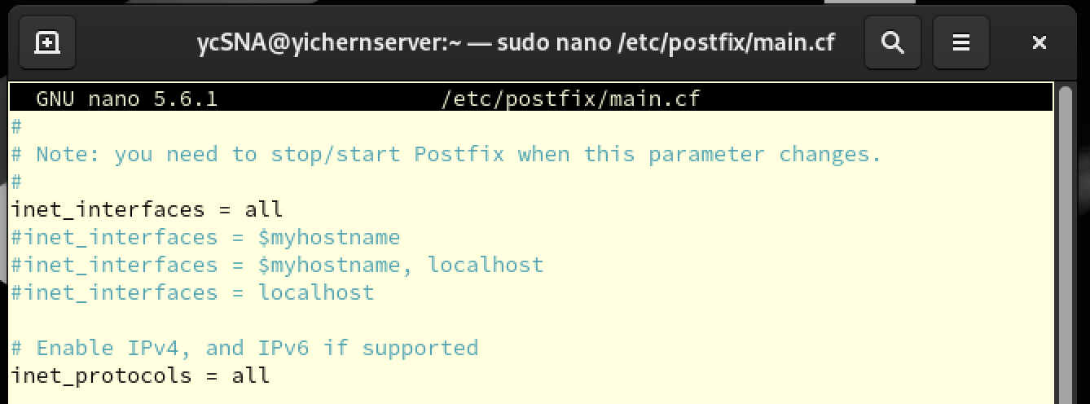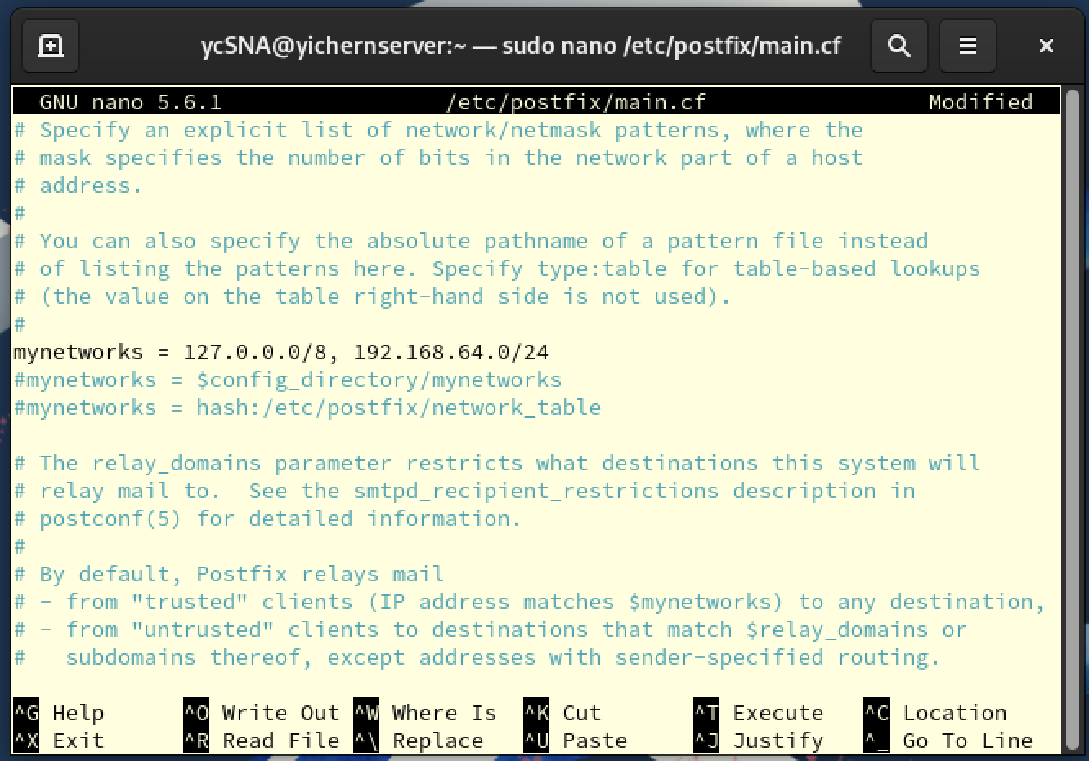

Explanation

* inet_interfaces = all

This tells Postfix listen incoming mail on all available network

* inet_protocols = all

This tells Postfix enable both internet protocol IPv4 and IPv6

* mynetwork = 127.0.0.0/8, 192.168.64.0/24

This tells Postfix which IP rages are considered trusted or internal.

127.0.0.0/8 is the loopback (locolhost) rage;

192.168.200.0/24 is our private LAN network, and we are allowing device on the same subnet to use this mail server.

Step 4: Config Mail Delivery Settings

* This step tells Postfix where to deliver local mail

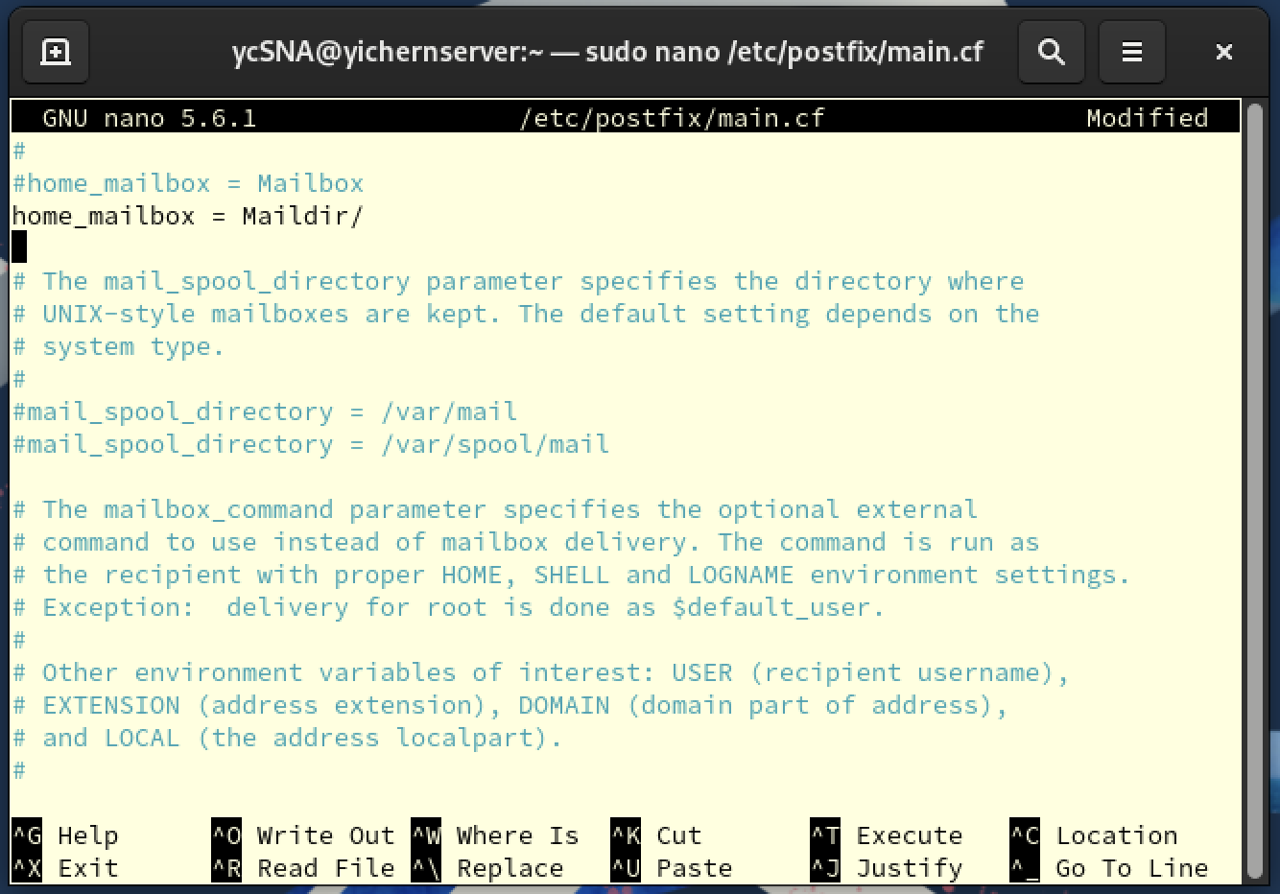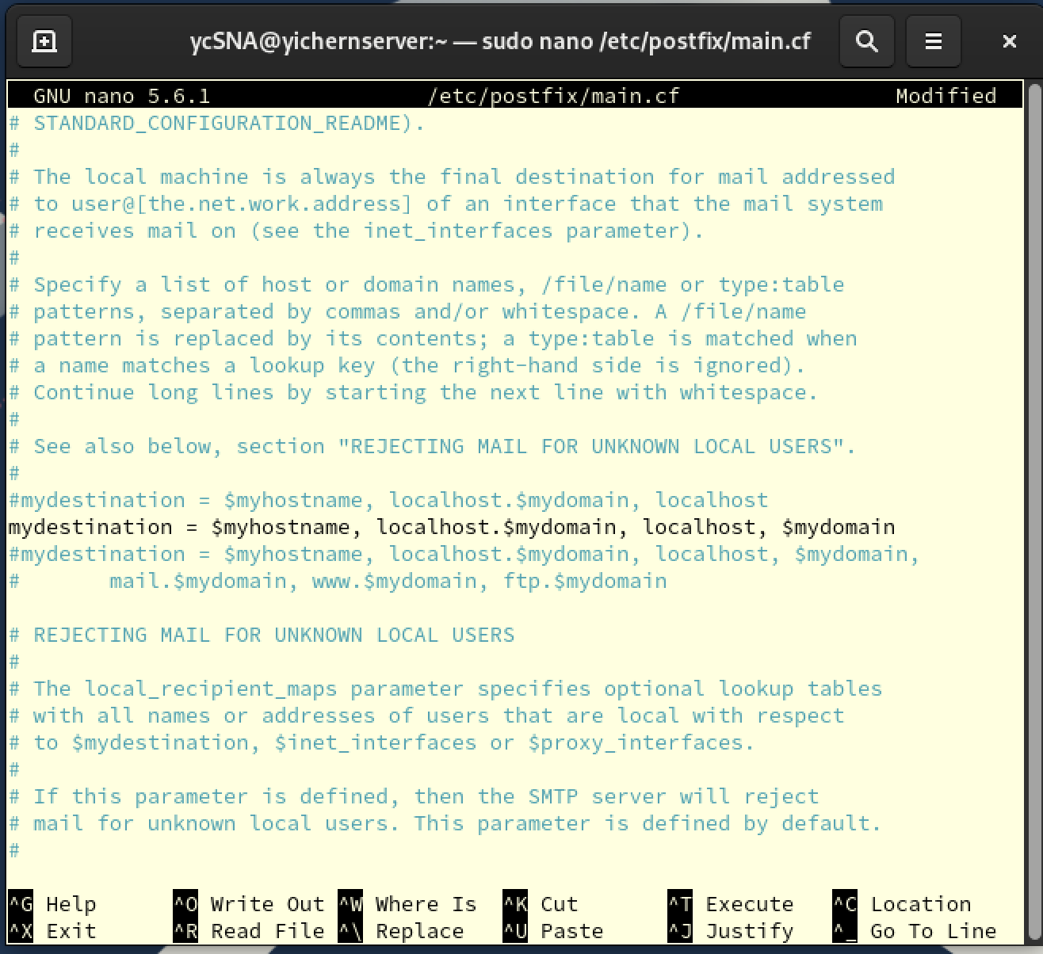

Explanation

* home_mailbox = Maildir/

This tells Postfix to deliver incoming mail to Maildir-format mailbox which located in their home directory.

* mydestination = $myhostname, localhost.$mydomain, localhost, $mydomain

This sets the list of domains that Postfix accept mail for local delivery.

Step 5: TLS/SSL Configuration and SASL Authentication

* This step enables and configure encryption and authentication for mail transfer.

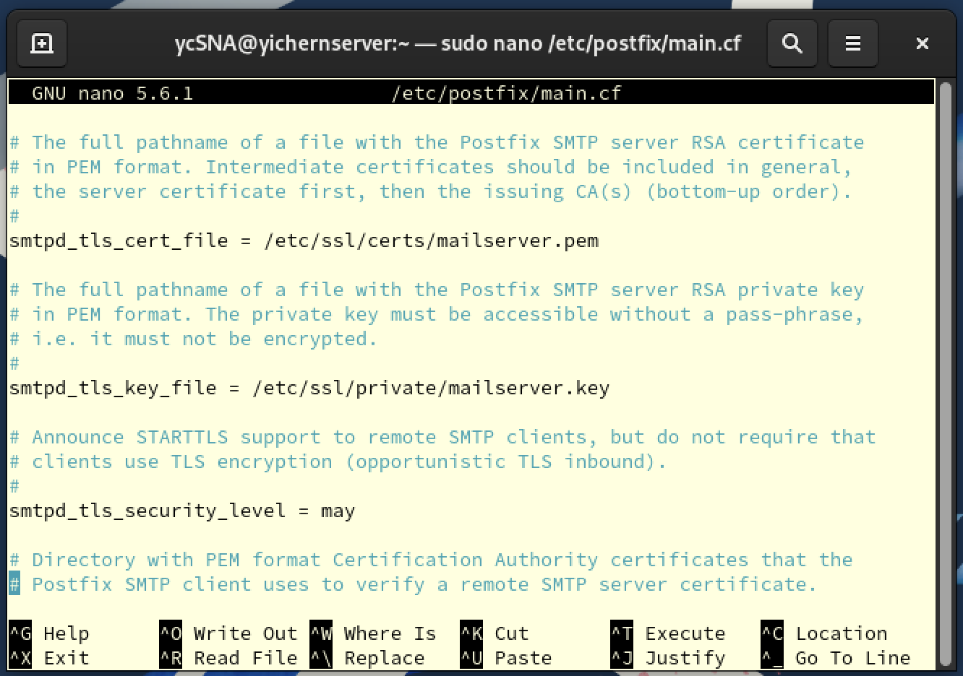

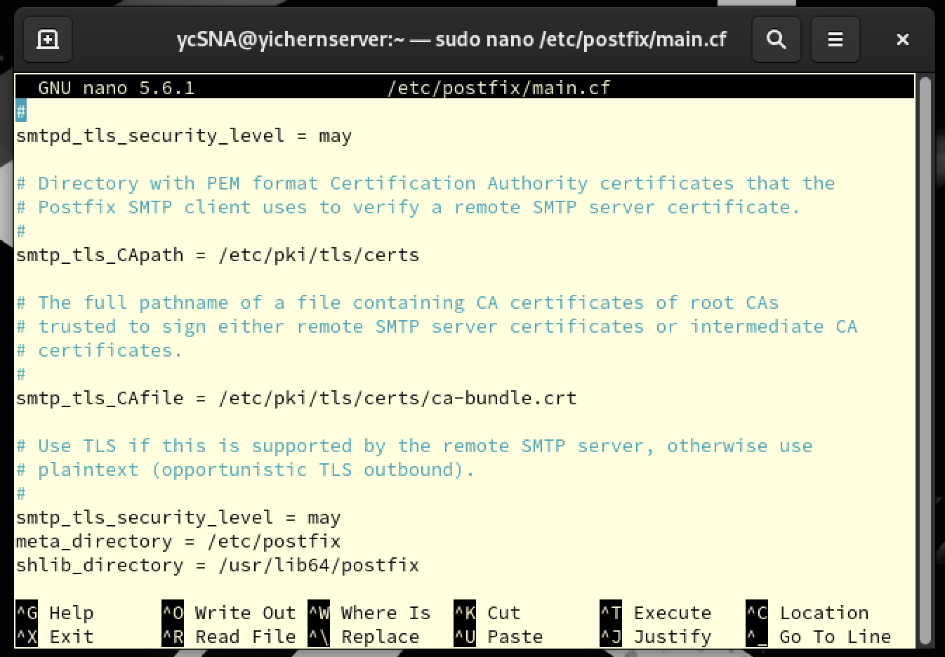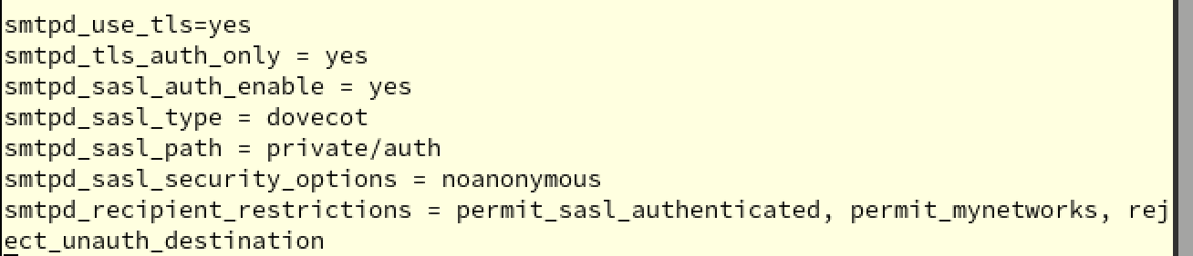

Explanation

TLS/SSL Configuration:

* + smtpd_tls_cert_file=/etc/ssl/certs/mailserver.pem
  + smtpd_tls_key_file=/etc/ssl/private/mailserver.key

These two command is to specifies the SSL certificate and private key file used by Postfix.

* + smtpd_use_tls=yes

Enables TLS encryption for incoming SMTP connections.

* + smtp_tls_security_level = may

Enable TLS when sending emails to other server.

* + smtpd_tls_security_level = may

Enable client (Thunderbird) to use TLS when sending mail.

* + smtpd_tls_auth_only = yes

Ensure authentication is only allowed over TLS.

SASL Authentication (via Dovecot):

* + smtpd_sasl_auth_enable = yes

Force client log in before sending mails.

* + smtpd_sasl_type = dovecot

Specifies Dovecot as the authentication backend.

* + smtpd_sasl_path = private/auth

Point Dovecot-auth socket to check login credentials.

* + smtpd_sasl_security_options = noanonymous

Blocks anonymous logins

* + smtpd_recipient_restrictions = permit_sasl_authenticated, permit_mynetworks, reject_unauth_destination

This is a list of policies which want Postfix to check before sending mails.

permit_sasl_authenticated: User successful authenticated

permit_mynetworks: User with trusted network

reject_unauth_destination: Reject when mail from user who doesn’t authenticate and in untrusted network

Step 6: Enter Postfix master config file

* sudo nano /etc/postfix/master.cf

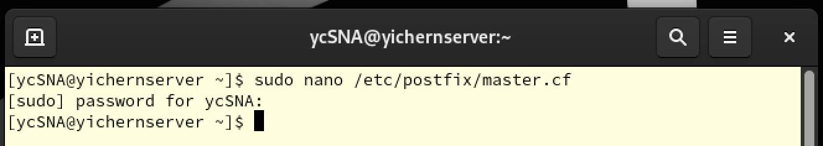

Step 7: Enable submission ports

* We are going to enable some of the ports (like 587 or 465) listen to Postfix

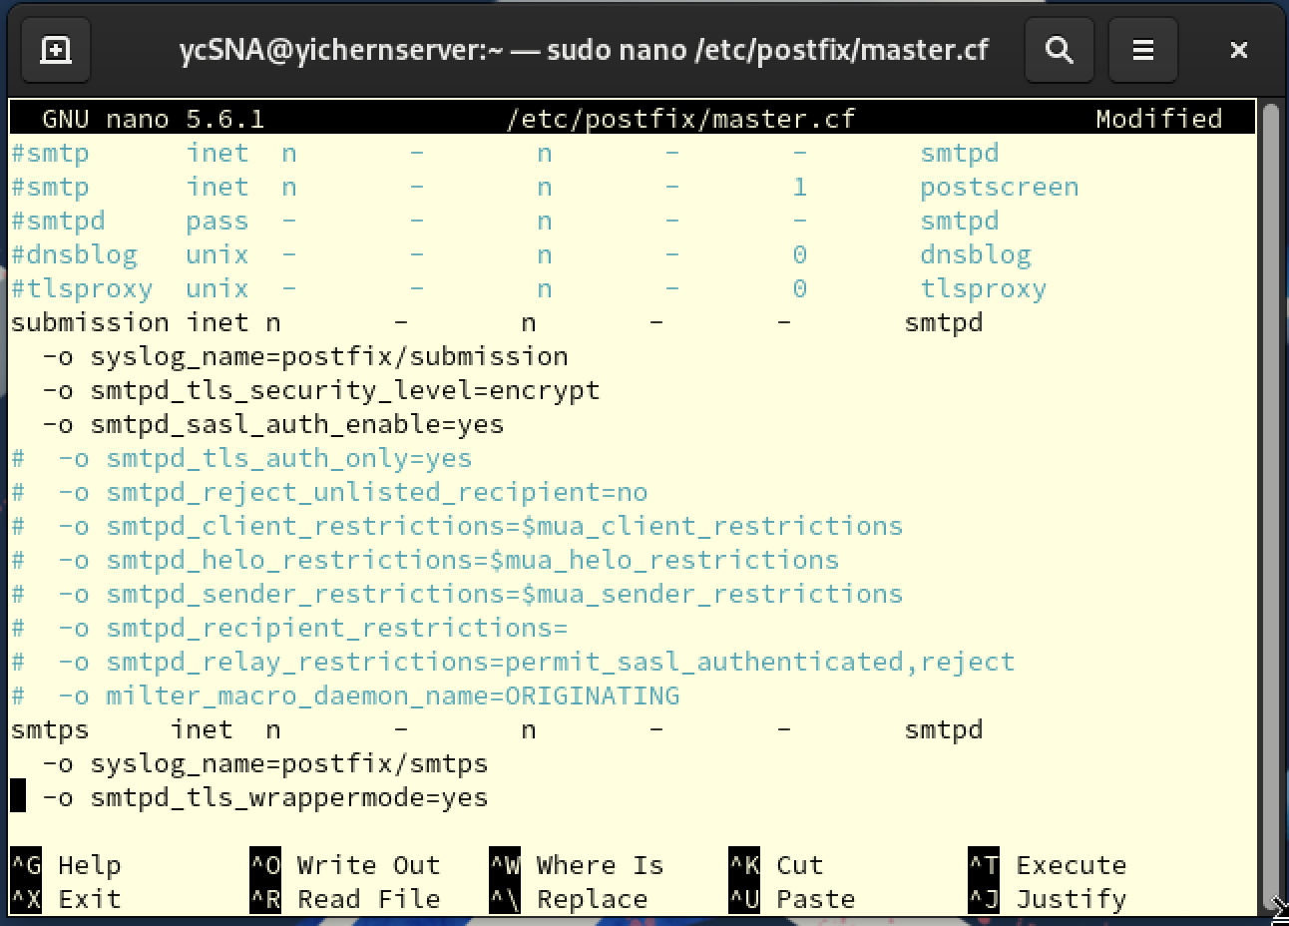

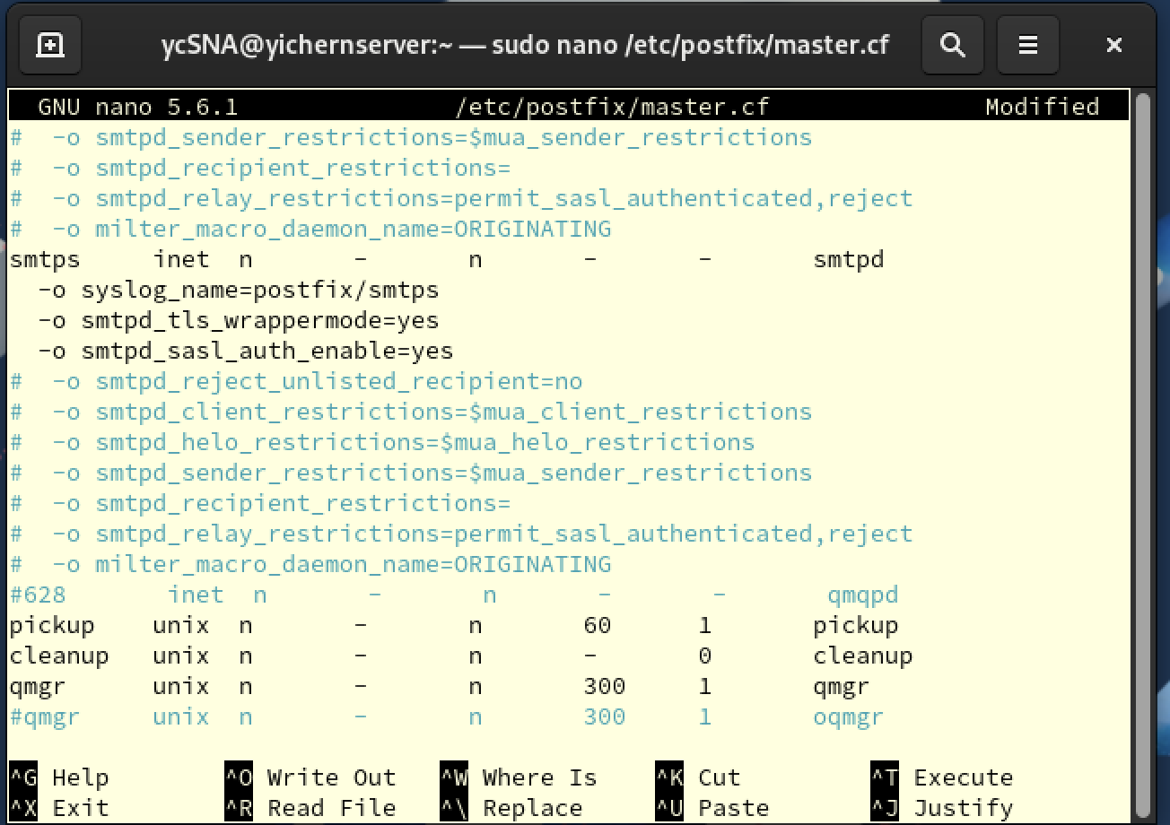

Explanation

submission: submission port (port 587) is port for sending mail from client

smtps: smtps port (port 465) is an older method that use implicit TLS

* syslog_name=postfix/submission; syslog_name=postfix/submission

Set both port listen to Postfix.

* smtpd_tls_security_level=encrypt; smtpd_tls_security_level=encrypt

Forces encryption via STARTTLS.

* smtpd_sasl_auth_enable=yes; smtpd_sasl_auth_enable=yes
* Enable SASL authentiacation.

Step 8: Restart Postfix

* After configuration, we need to reload Postfix.
* sudo systemctl restart postfix

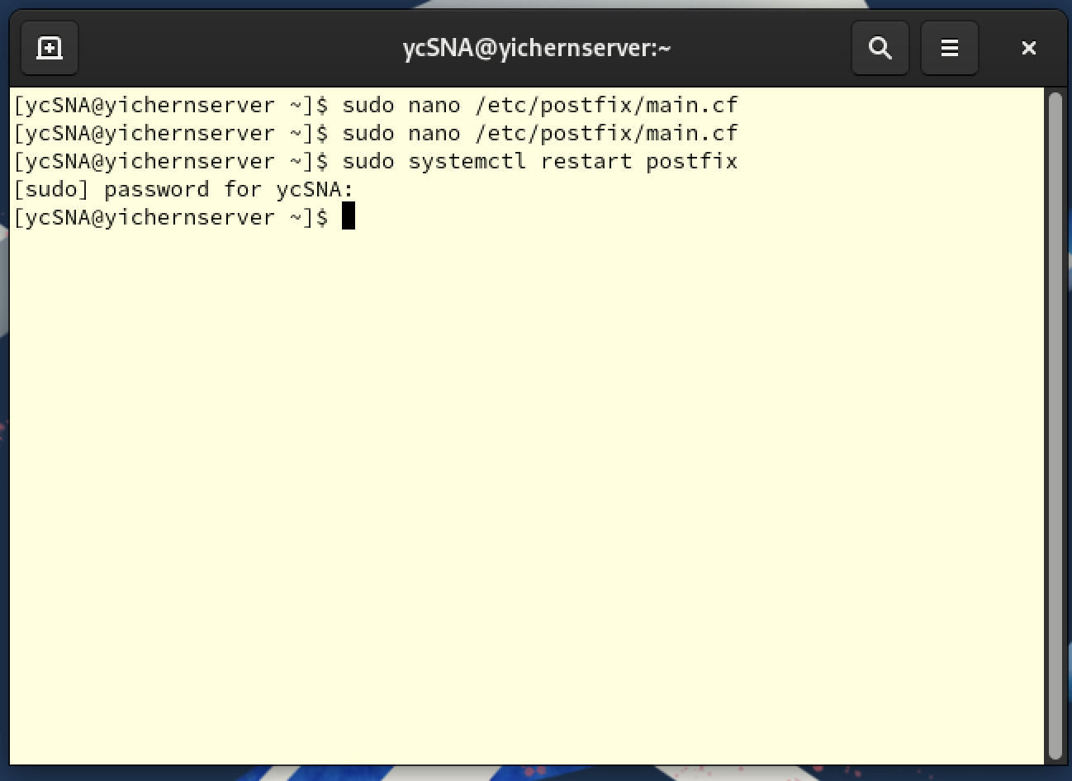

Step 9: Allow email traffic (SMTP)

* **This step is to tell my system allow email traffic (SMTP) through the firewall.** SMTP is standard protocol used by Postfix sending **emails,** and it's usually on **port 25.**
* sudo firewall-cmd --permanent --add-service=smtp
* Then we reload the firewall
* sudo firewall-cmd --reload

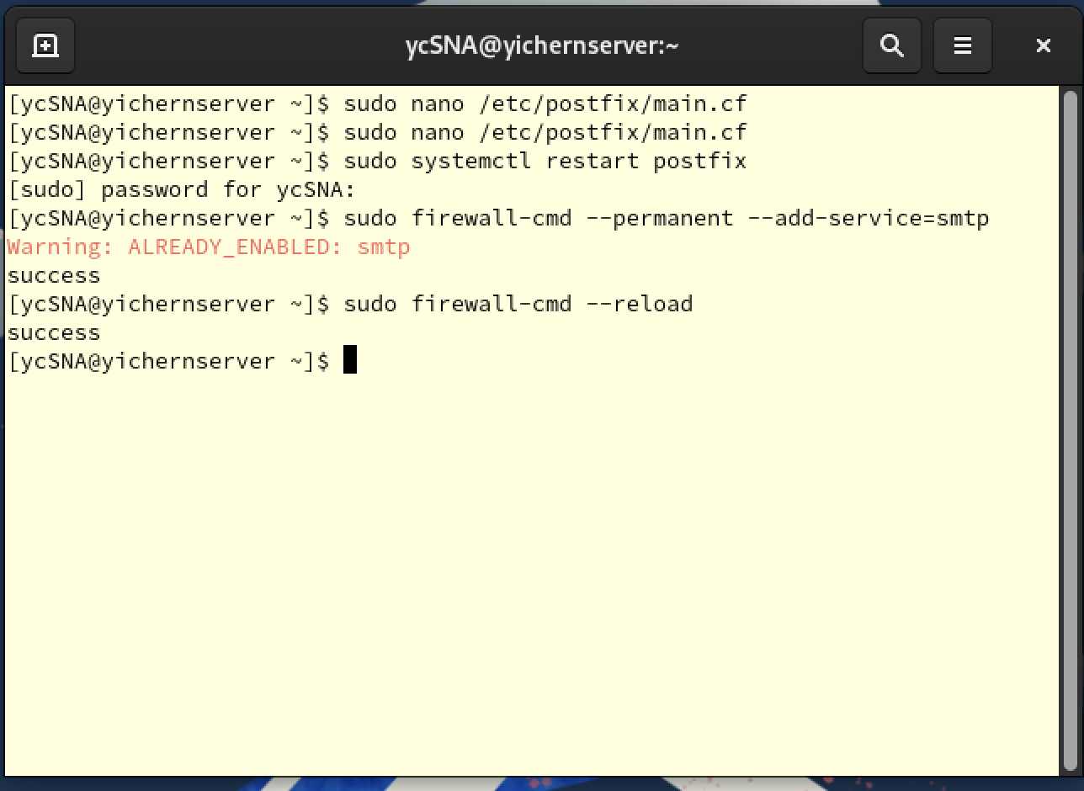

Explanation

* sudo firewall-cmd --permanent --add-service=smtp

--permanent: add rule permanently

--add-service=smtp: opens port 25, which is the standard SMTP port

# 4.0 Dovecot

Dovecot is a Mail Delivery Agent (MDA), which is a computer software component that delivers message to users’ mailbox and supports client access. It is also an efficient and secure open-source IMAP and POP server. It handles the retrieval side of the mail system which allows email clients to access, read, and manages store on the server.

In this assignment, we are installing and configuring Dovecot to ensure that users can securely log in to check and read their emails. At the same time, supporting Postfix with authentication services during outgoing mail transactions.

## 4.1 Installation of Dovecot

Step 1: Install Dovecot

* sudo dnf install dovecot -y

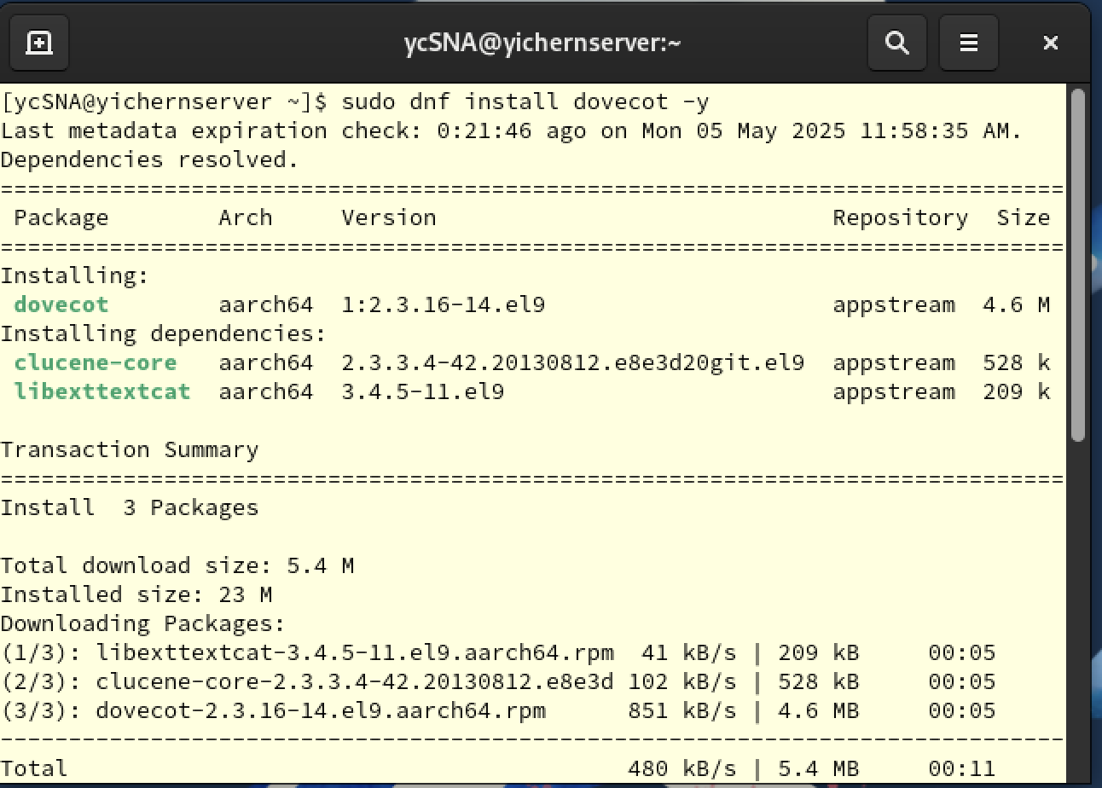

Step 2: Enable and start Dovecot

* + sudo systemctl enable postfix
  + sudo systemctl start postfix
  + sudo systemctl status postfix

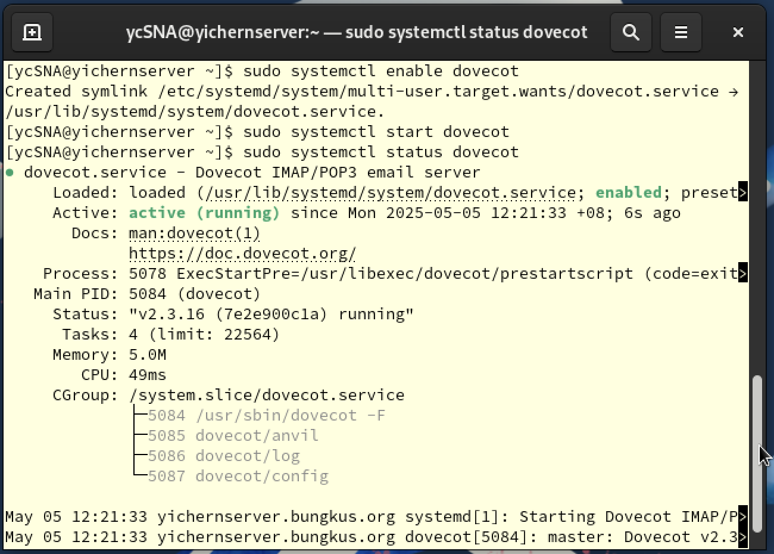

## 4.2 Configuration of Dovecot

Step 1: Enter Dovecot Protocol configuration file

* sudo nano /etc/dovecot/dovecot.conf

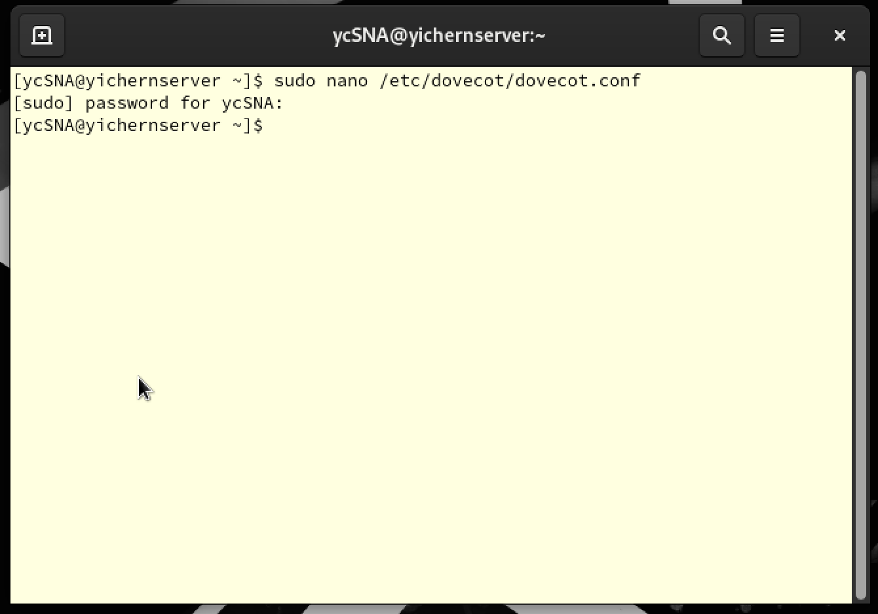

Step 2: Enable Required Protocols

* This tells Dovecot to support three protocols, IMAP (syncing mail folders), POP3 (downloading emails) and LMTP (delivering mail from Postfix to Dovecot)

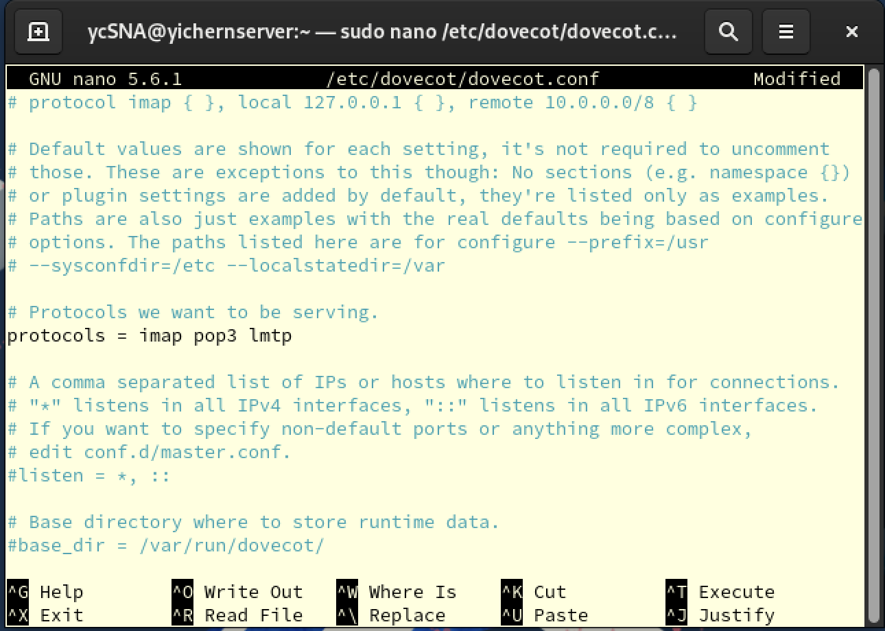

Explanation

* + protocols = imap pop3 lmtp

We enable these three protocol which is imap pop3 lmtp for our mail service.

IMAP: Internet Message Access Protocol, allows email clients (Thunderbird) to view and manage mail on server.

POP3: Post Office Protocol, let email clients download email from the server to the local machine.

LMTP: Local Mail Transfer Protocol, used by Postfix to deliver mail to Dovecot’s local user mailboxes.

Step 3: Enter Mail Storage Configuration File

* sudo nano /etc/dovecot/conf.d/10-mail.conf

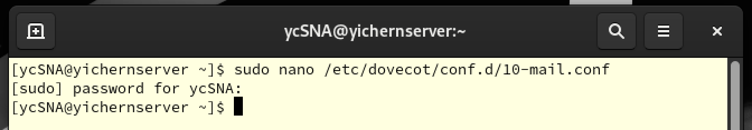

Step 4: Set Mail Storage Location

* We define **where** Dovecot looks for and stores user emails

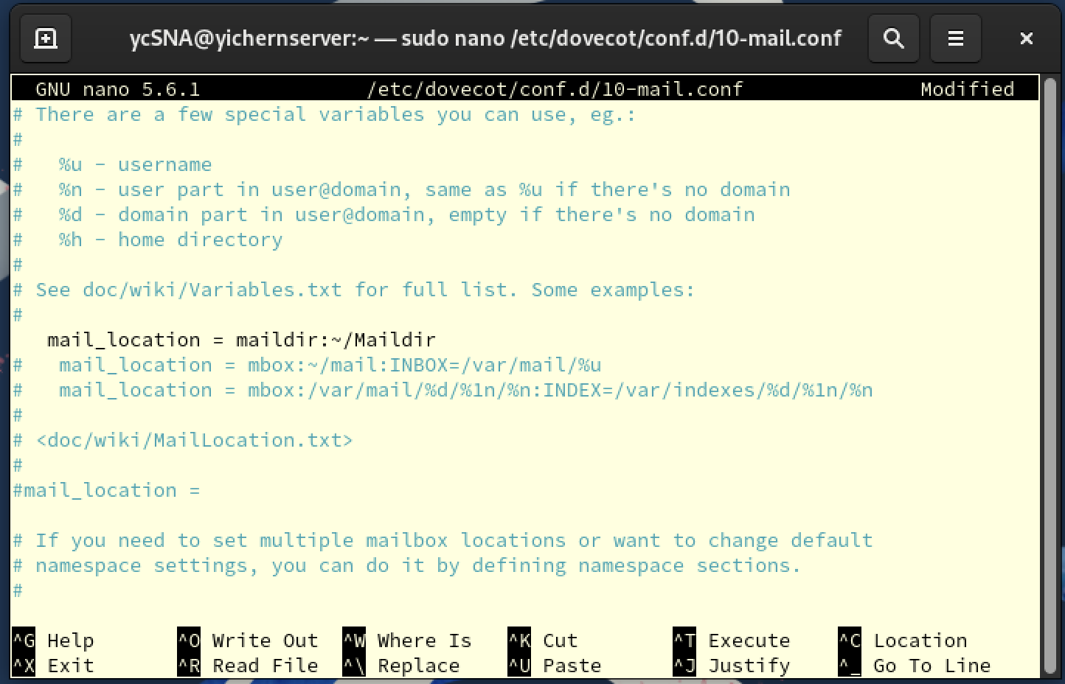

Explanation

* + mail_location = maildir:~/Maildir

Tells Dovecot where the mail should be store.

Step 5: Enter Mail Authentication Settings File

* sudo nano /etc/dovecot/conf.d/10-auth.conf

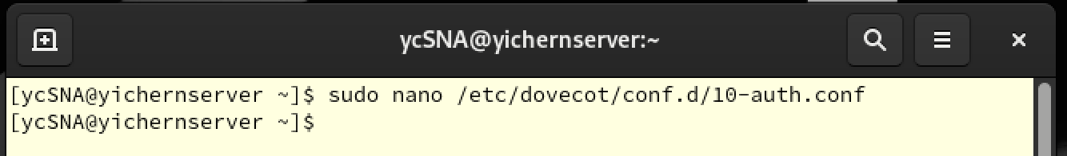

Step 6: Enable Plain Text Auth (will secure later)

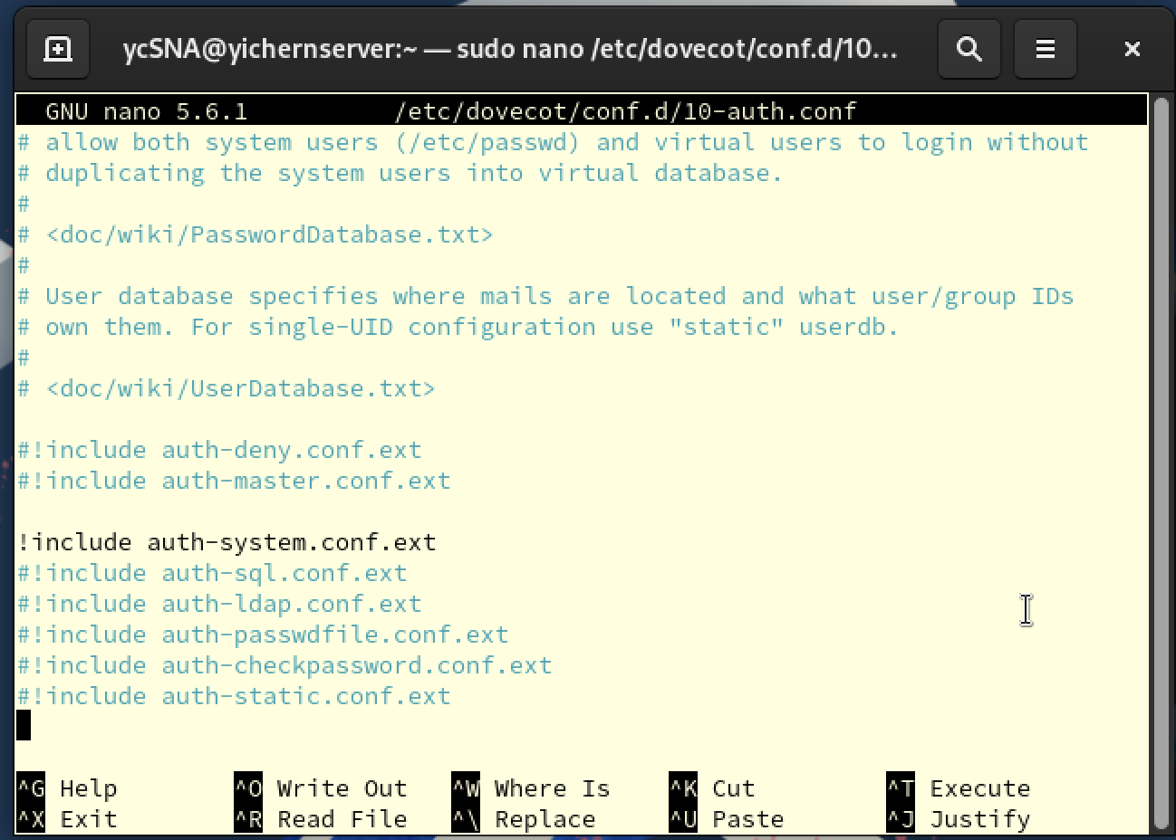

Explanation

* + !include auth-system.conf.ext

We pull the configution from auth-system.conf.ext to let Dovecot use the system’s user account for authentication.

Step 7: Open IMAP and POP3 ports in Firewall

* Now we are allowing incoming connections for IMAP and POP3 which let our email client (Thunderbird) **retrieve mail from the server**.
* sudo firewall-cmd --permanent --add-service=imap
* sudo firewall-cmd --permanent --add-service=pop3
* sudo firewall-cmd --reload

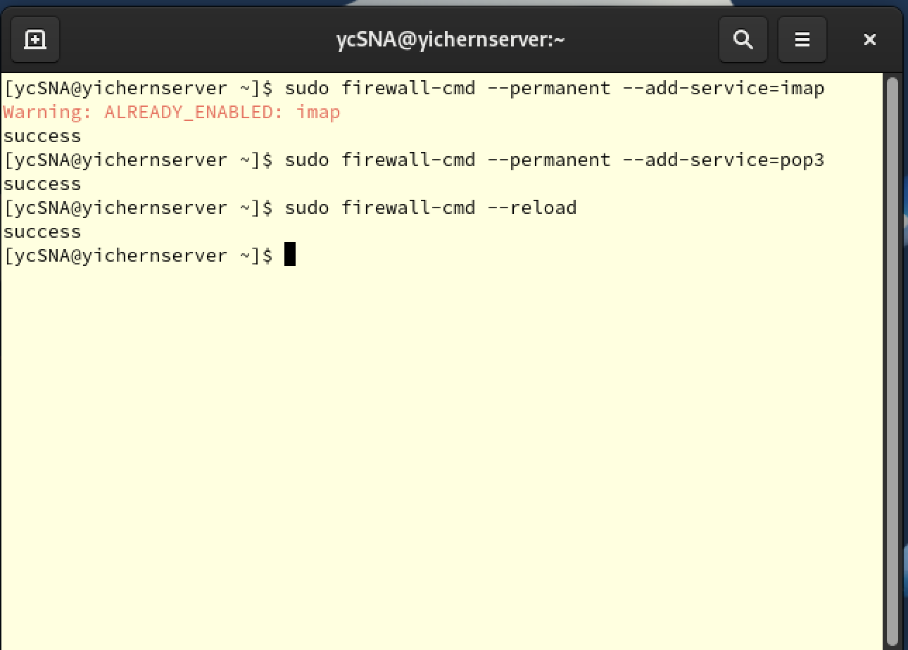

Explanation

* sudo firewall-cmd --permanent --add-service=imap
* sudo firewall-cmd --permanent --add-service=pop3

--add-service=imap: opens port 143 which used by Dovecot for IMAP protocol

--add-service=pop3: opens port 110 which used by Dovecot for POP3 protocol

Step 8: Restart Dovecot

* sudo systemctl restart dovecot

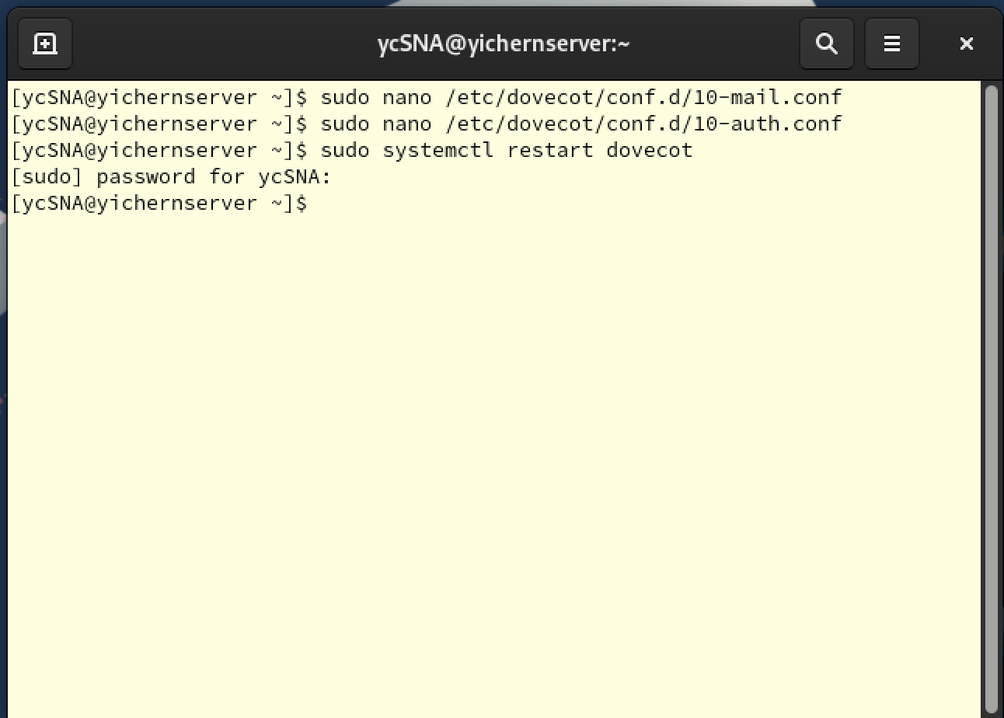

Step 9: Check Dovecot status

* sudo systemctl status dovecot

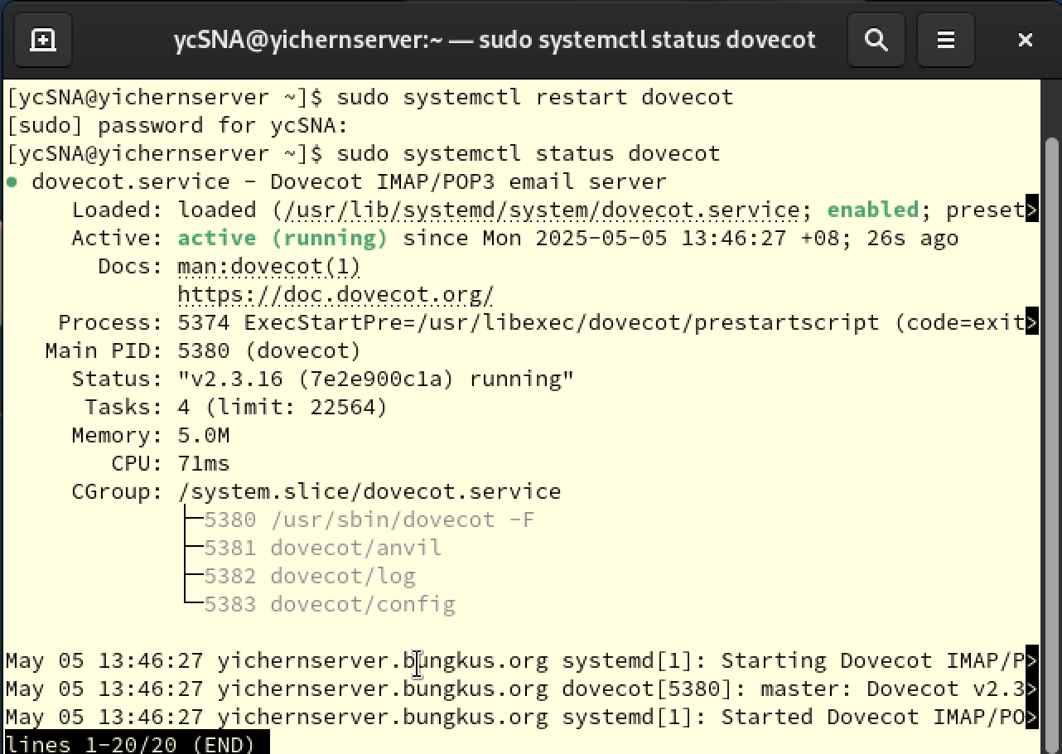

# 5.0 SSL

SSL, Secure Sockets Layers plays a crucial role in encrypt email communication while data exchanged between mail server and client. SSL ensure that username, passwords and message contents are not transmitted in plaintext, prevent man-in-the-middle attacks.

In this assignment, we are going to configure SSL for Postfix and Dovecot to secure email transmission and retrieval. To achieve this, we will generate a self-signed SSL certificates to allow the email encryption between email server and client. However, because of the certificates are self-signed, it is not issued by any trusted Certificate Authority (CA). Hence, they will not be recognized by public email services or external users. This setup is only sufficient for testing or private network use.

Step 1: Install SSL

* sudo dnf install openssl

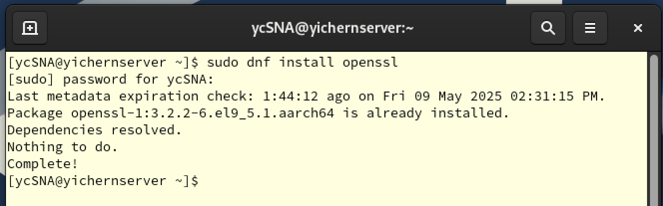

Step 2: Create a certificate directory

* At first, we create a directory named private under /etc/ssl to store our private key file and certificate.
* sudo mkdir -p /etc/ssl/private

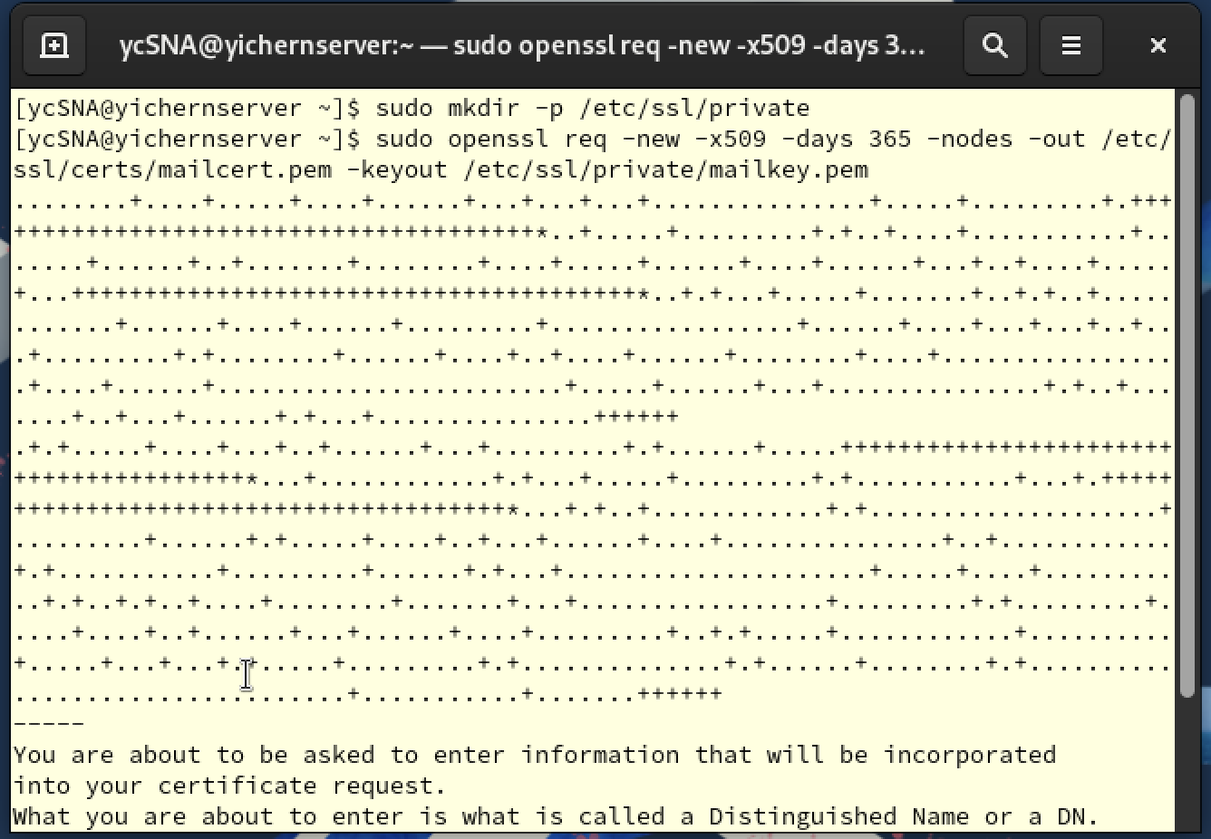

Explanation

We create a directory /etc/ssl/private to store the certificate we going to create.

Step 3: Generate a certificate

* Now we enter following command to generate the certificate
* sudo openssl req -new -x509 -days 365 -nodes -out /etc/ssl/certs/mailcert.pem -keyout /etc/ssl/private/mailkey.pem

  
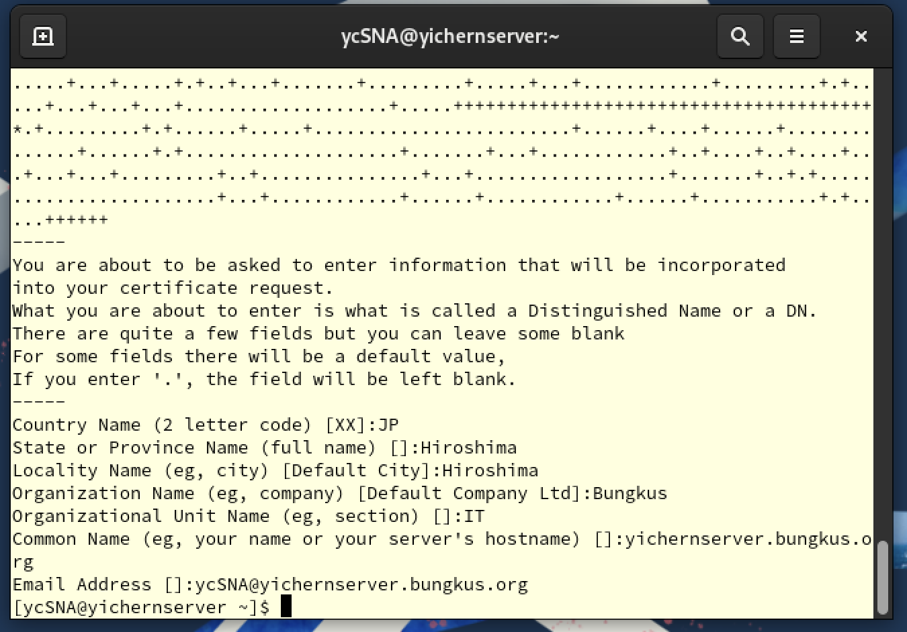

Explanation

* + openssl req -new -x509

Creates a new certificate using X.509 standard.

* + -days 365

Valid for 365 days.

* + -nodes

Skips the passphrase.

* + -out /etc/ssl/certs/mailcert.pem

Output file for the certificate.

* + -keyout /etc/ssl/private/mailkey.pem

Output file for the private key.

Step 4: Set appropriate permission

* sudo chmod 600 /etc/ssl/private/mailkey.pem

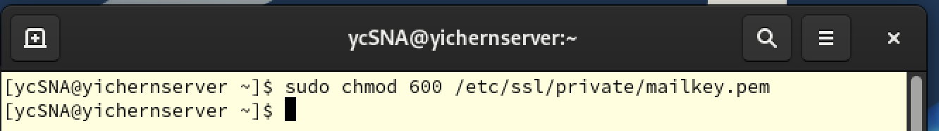

Explanation

We set the /etc/ssl/private/mailkey.pem permission as 600 which only allow file’s owner read and write and no permission to others.

Step 5: Enable Authentication Socket (for Postfix)

* In this step, we configure Dovecot to expose an authentication socket that Postfix can access
* Open Dovecot master config
* sudo nano /etc/dovecot/conf.d/10-master.conf

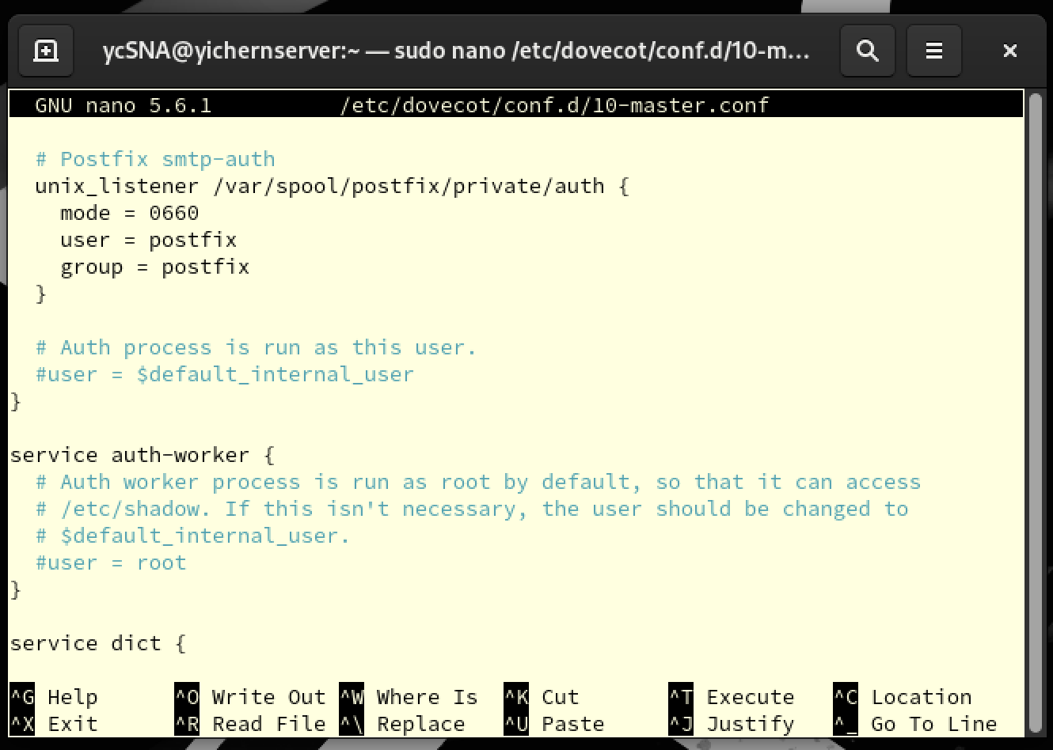

Explanation

* unix_listener /var/spool/postfix/private/auth

Unix listener is a “door” to let other service connect to dovecot. The location is set is to let Postfix find the path when it wants to authenticate someone.

* mode = 0660

This set the file permission which only allow owner and group read or write.

* user = postfix; group = postfix

This set that the socket is owned/belong to Postfix user/group.

Step 6: Configure Dovecot to use TLS

* Open Dovecot config file with following command
* sudo nano /etc/dovecot/conf.d/10-ssl.conf
* Edit or uncomment following lines

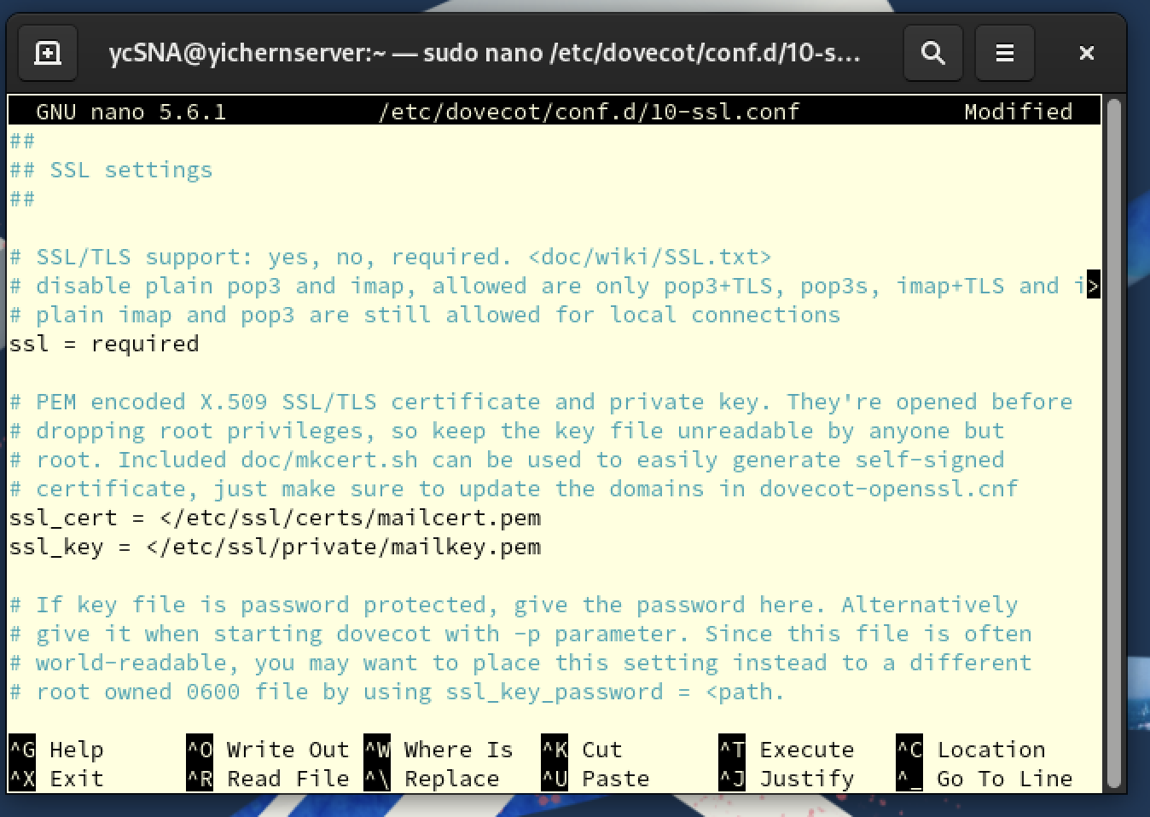

Explanation

* + **ssl = required**

Ensures TLS is mandatory for incoming connections.

* + **ssl_cert**

Path to the SSL certificate.

* + **ssl_key**

Path to the private key that use for the remaining SSL certificate.

Step 7: Restart and check both Postfix and Dovecot status

* sudo systemctl restart postfix
* sudo systemctl restart dovecot

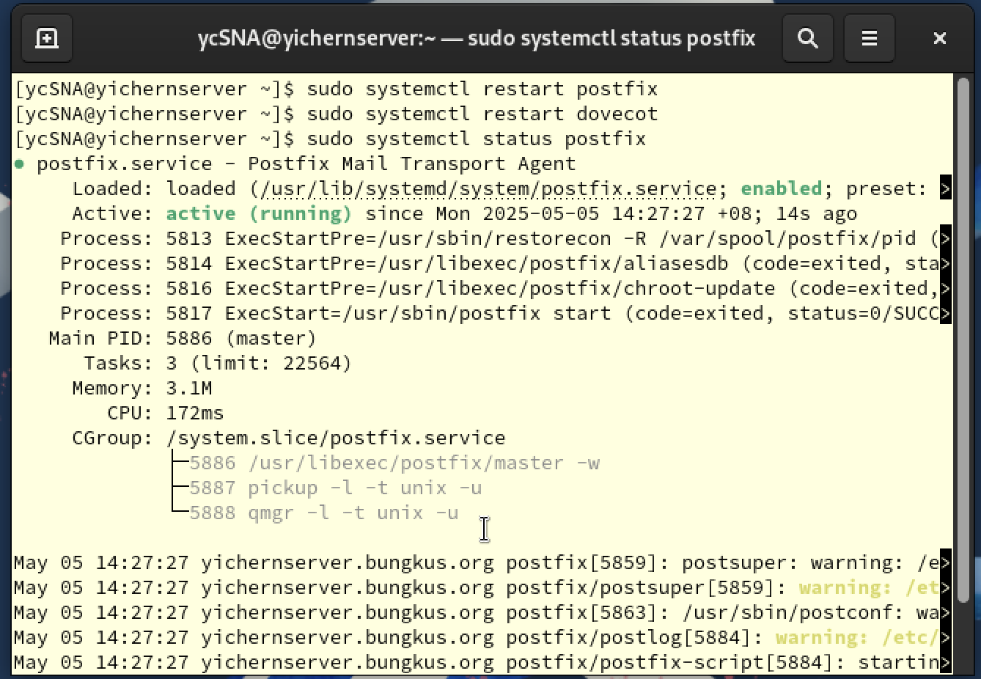  
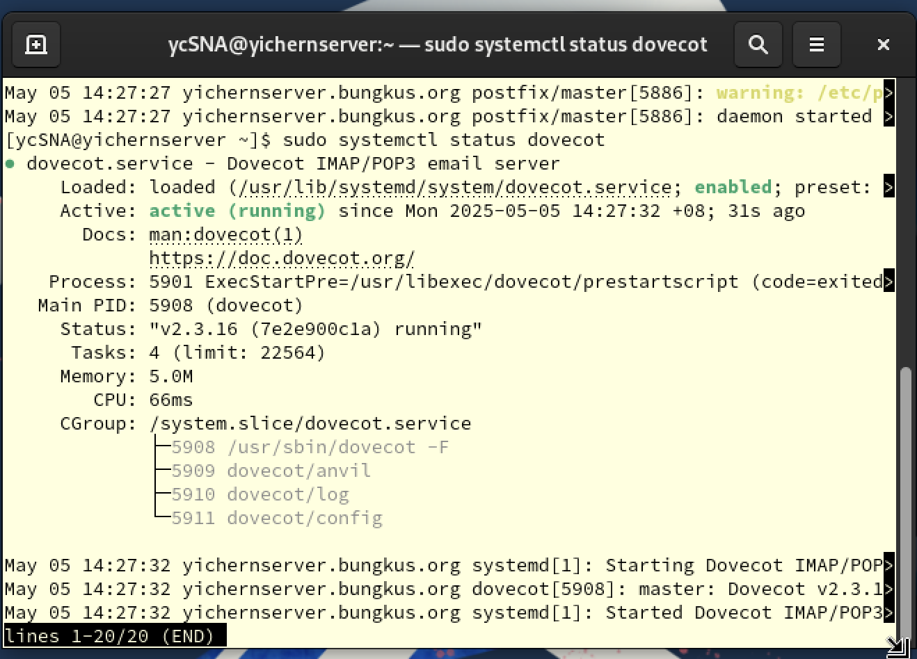

Step 8: Configure all Firewall

* sudo firewall-cmd --permanent --add-port=587/tcp
* sudo firewall-cmd --permanent --add-port=465/tcp
* sudo firewall-cmd --permanent --add-port=993/tcp
* sudo firewall-cmd --reload

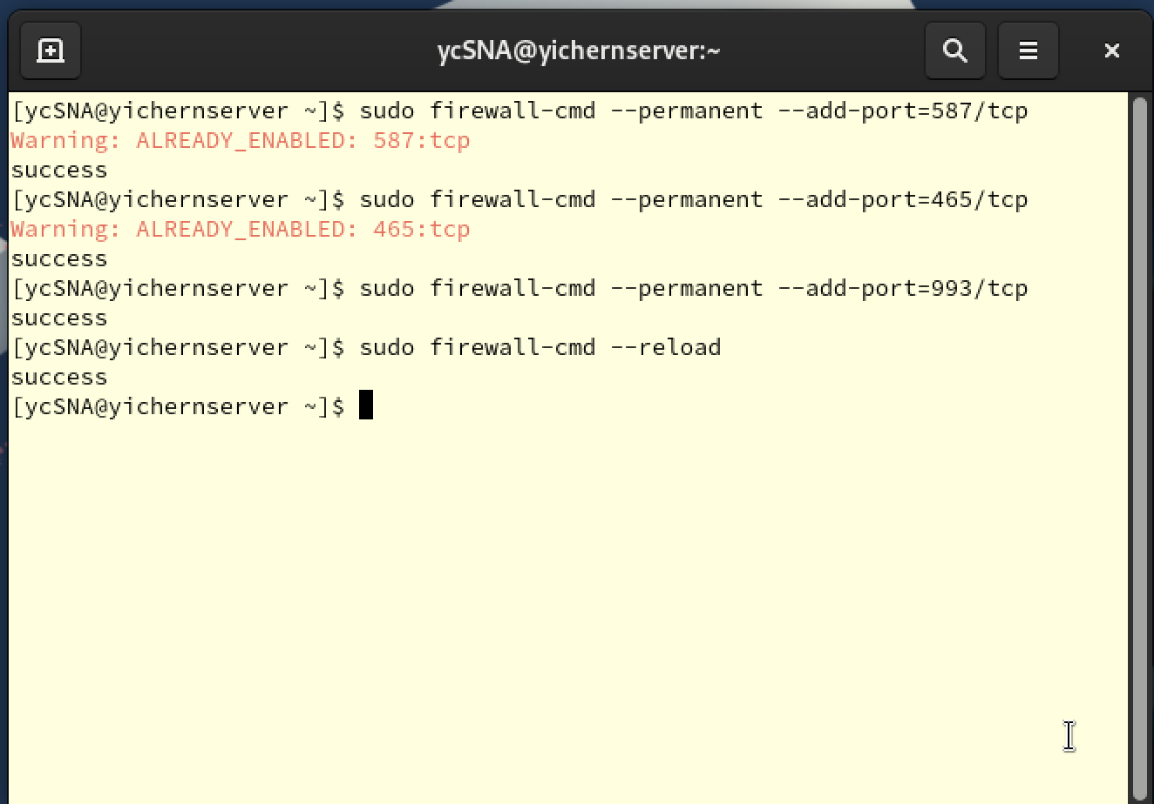

Explanation

Make sure again all port are been added.

Port 587: SMTP submission

Port 465: SMTPS (SMTP over SSL)

Port 993: IMAPS (IMAP over SSL)

# 6.0 Mozilla Thunderbird

Mozilla Thunderbird is an open-source email client which designed to manage email, newsgroup, and feeds in one application.

In this assignment, Thunderbird responsible for prompting interface through which users can send and receive emails from the Postfix and Dovecot mail server we have configured. It allows us to test the entire mail flow.

Step 1: Install Thunderbird

* sudo apt install thunderbird -y

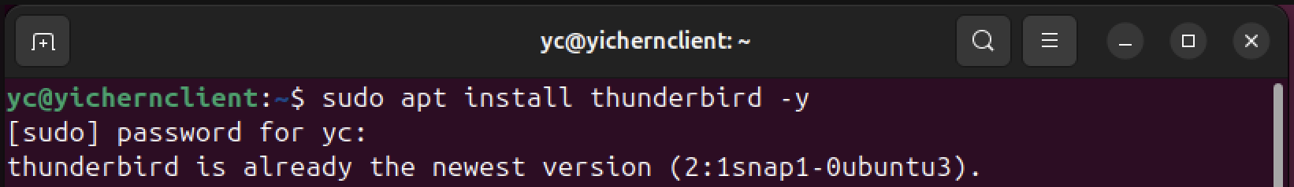

Step 2: Open Thunderbird

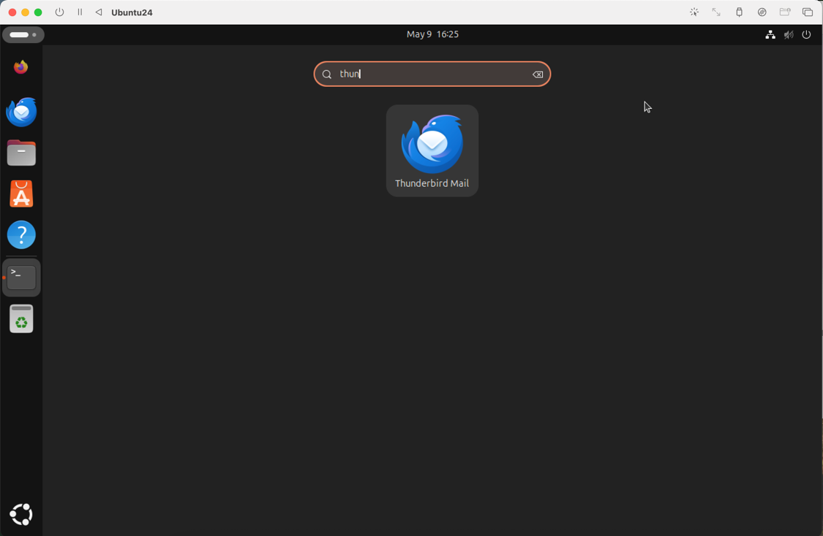

Step 3: Login Thunderbird

* Login by using your Rocky account name, Email address with corresponding domain and Password.

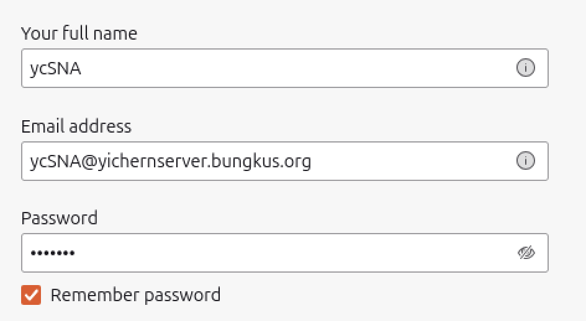

Step 4: Configure Manually

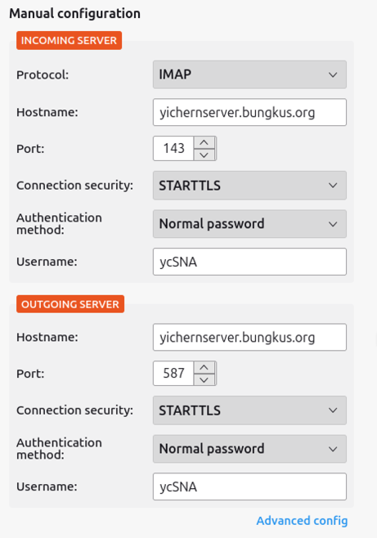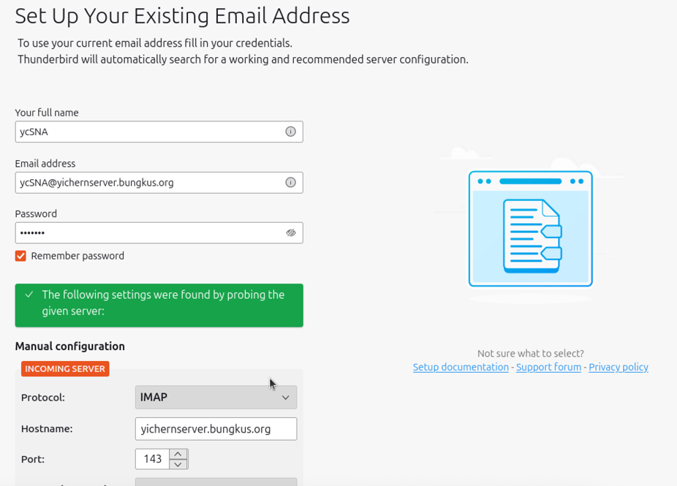

* Incoming Server using IMAP, STARTTLS (port 143); Outgoing Server using STARTLS (port587).
* In this stage, the system should show the green box like the figure given.

Step 5: Add Security Exception

* After logging in, the system will require to add security exception. This is because the certificate is created without any trusted CA, hence we need to except it from here.

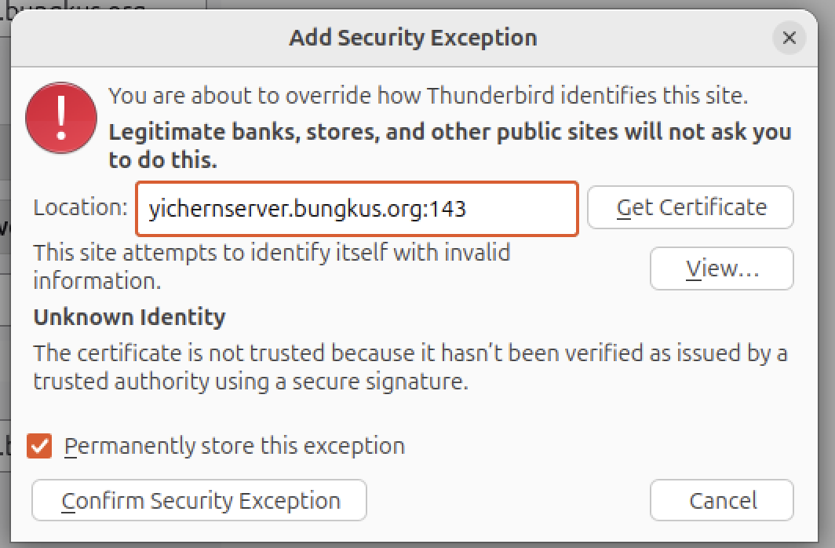

Step 6: Successful log in

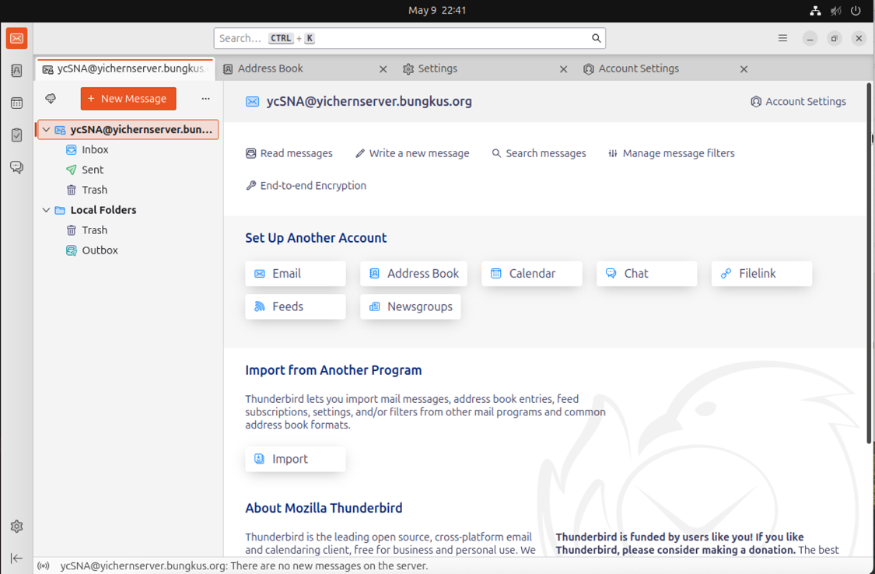

# 7.0 Test Email

After installed and configured all services. We are going to test whether the mail system function.

Step 1: Send an email to myself (ycSNA to ycSNA)

* Write a testing email

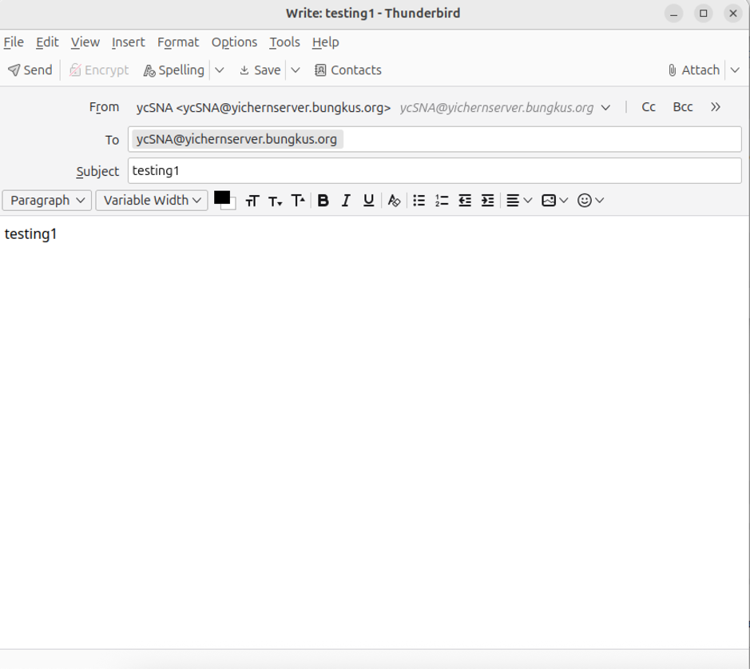

* It shows successful since we can see it in our inbox.

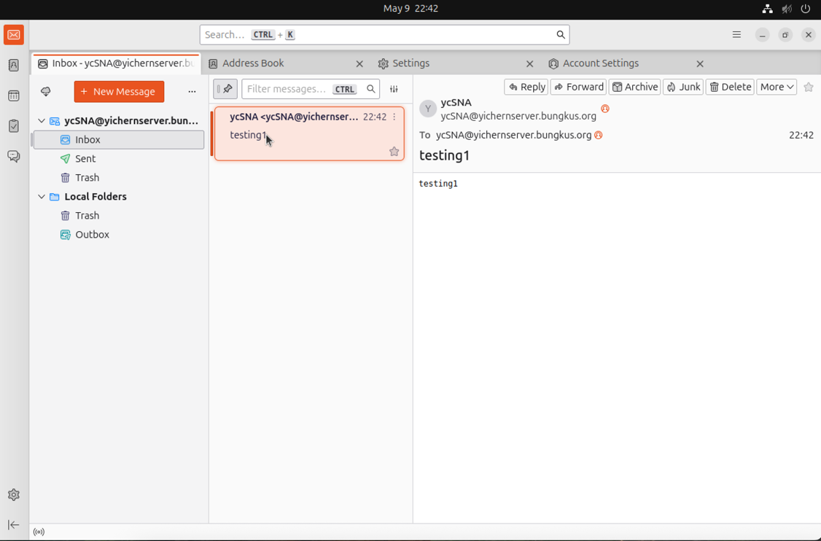

Step 2: Send email from different user (batman to ycSNA)

* At first, we need to enter our rocky to create a new user

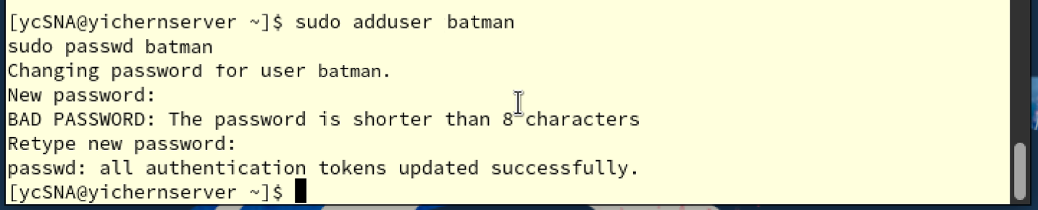

* Next, we create a new account in Thunderbird

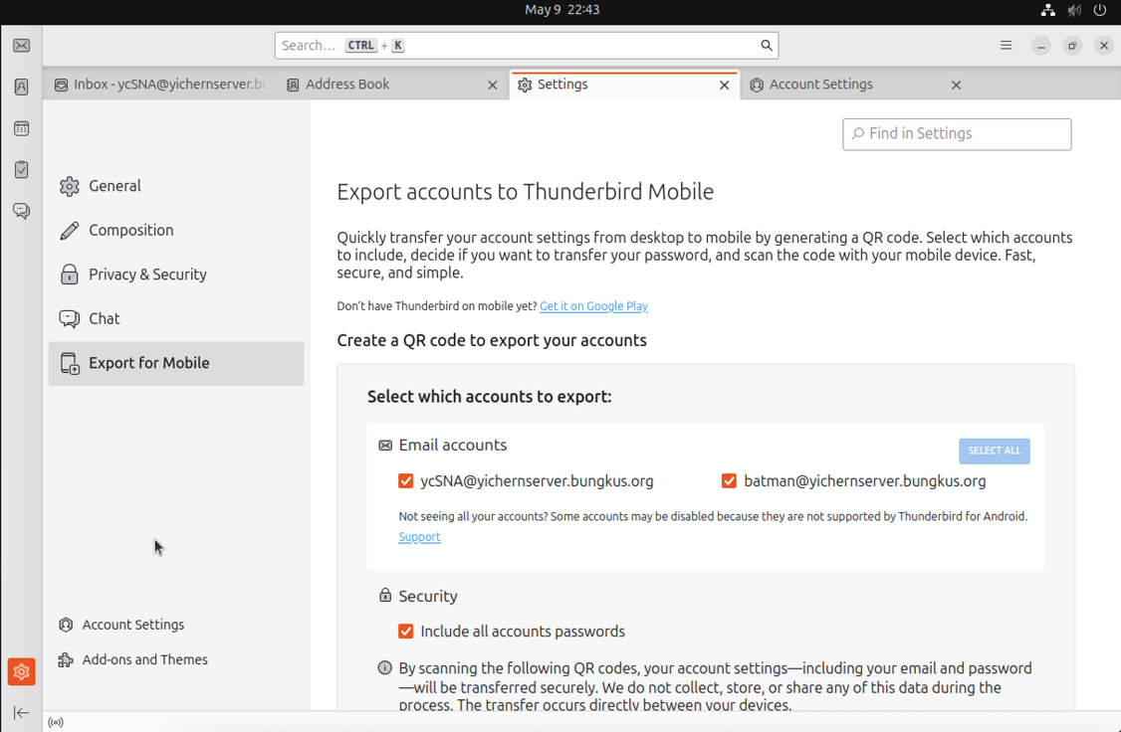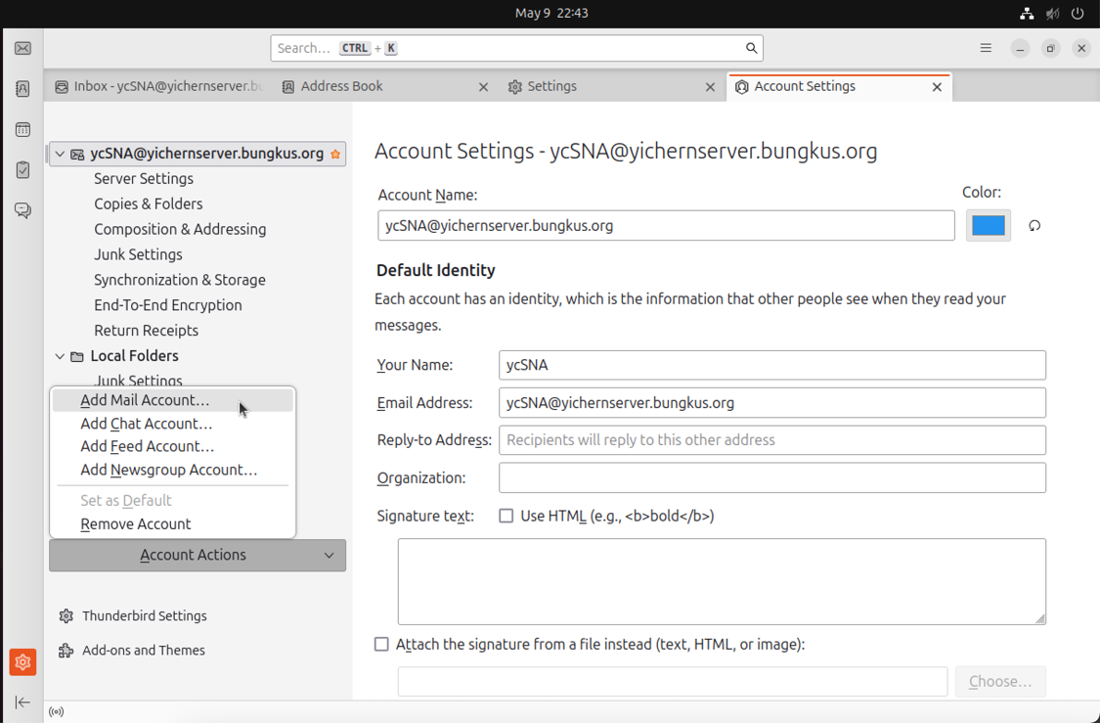

2

1

2

1

* Next, log in with other account.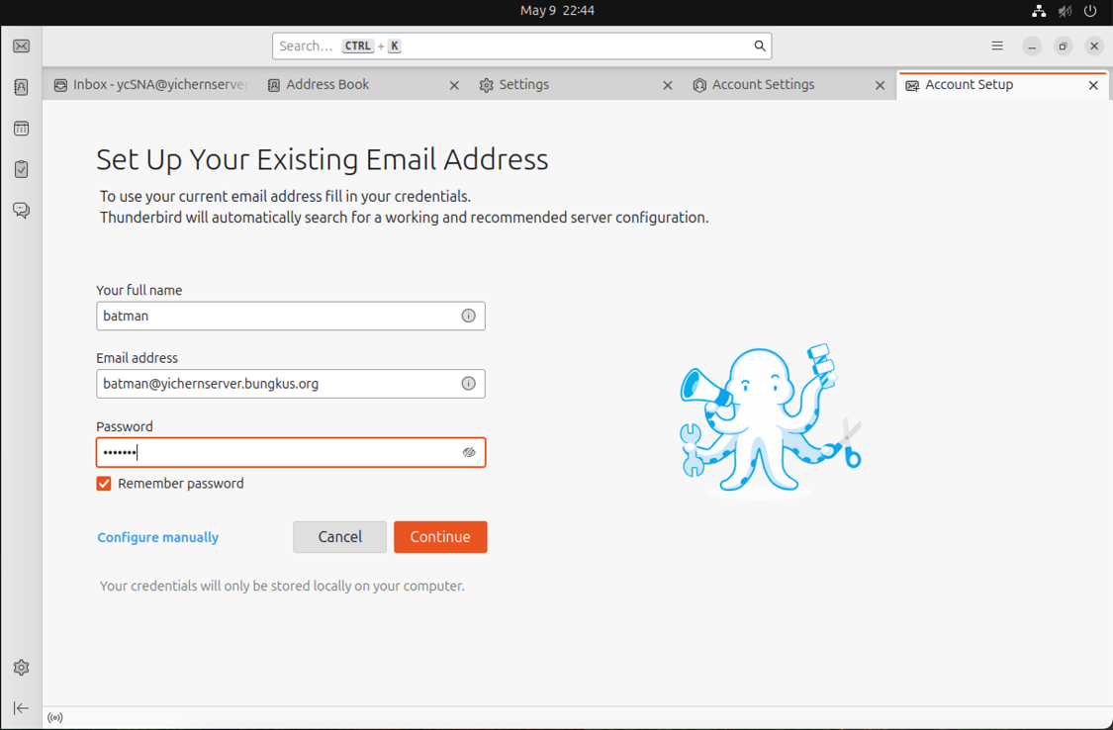
* Finally send an email to ycSNA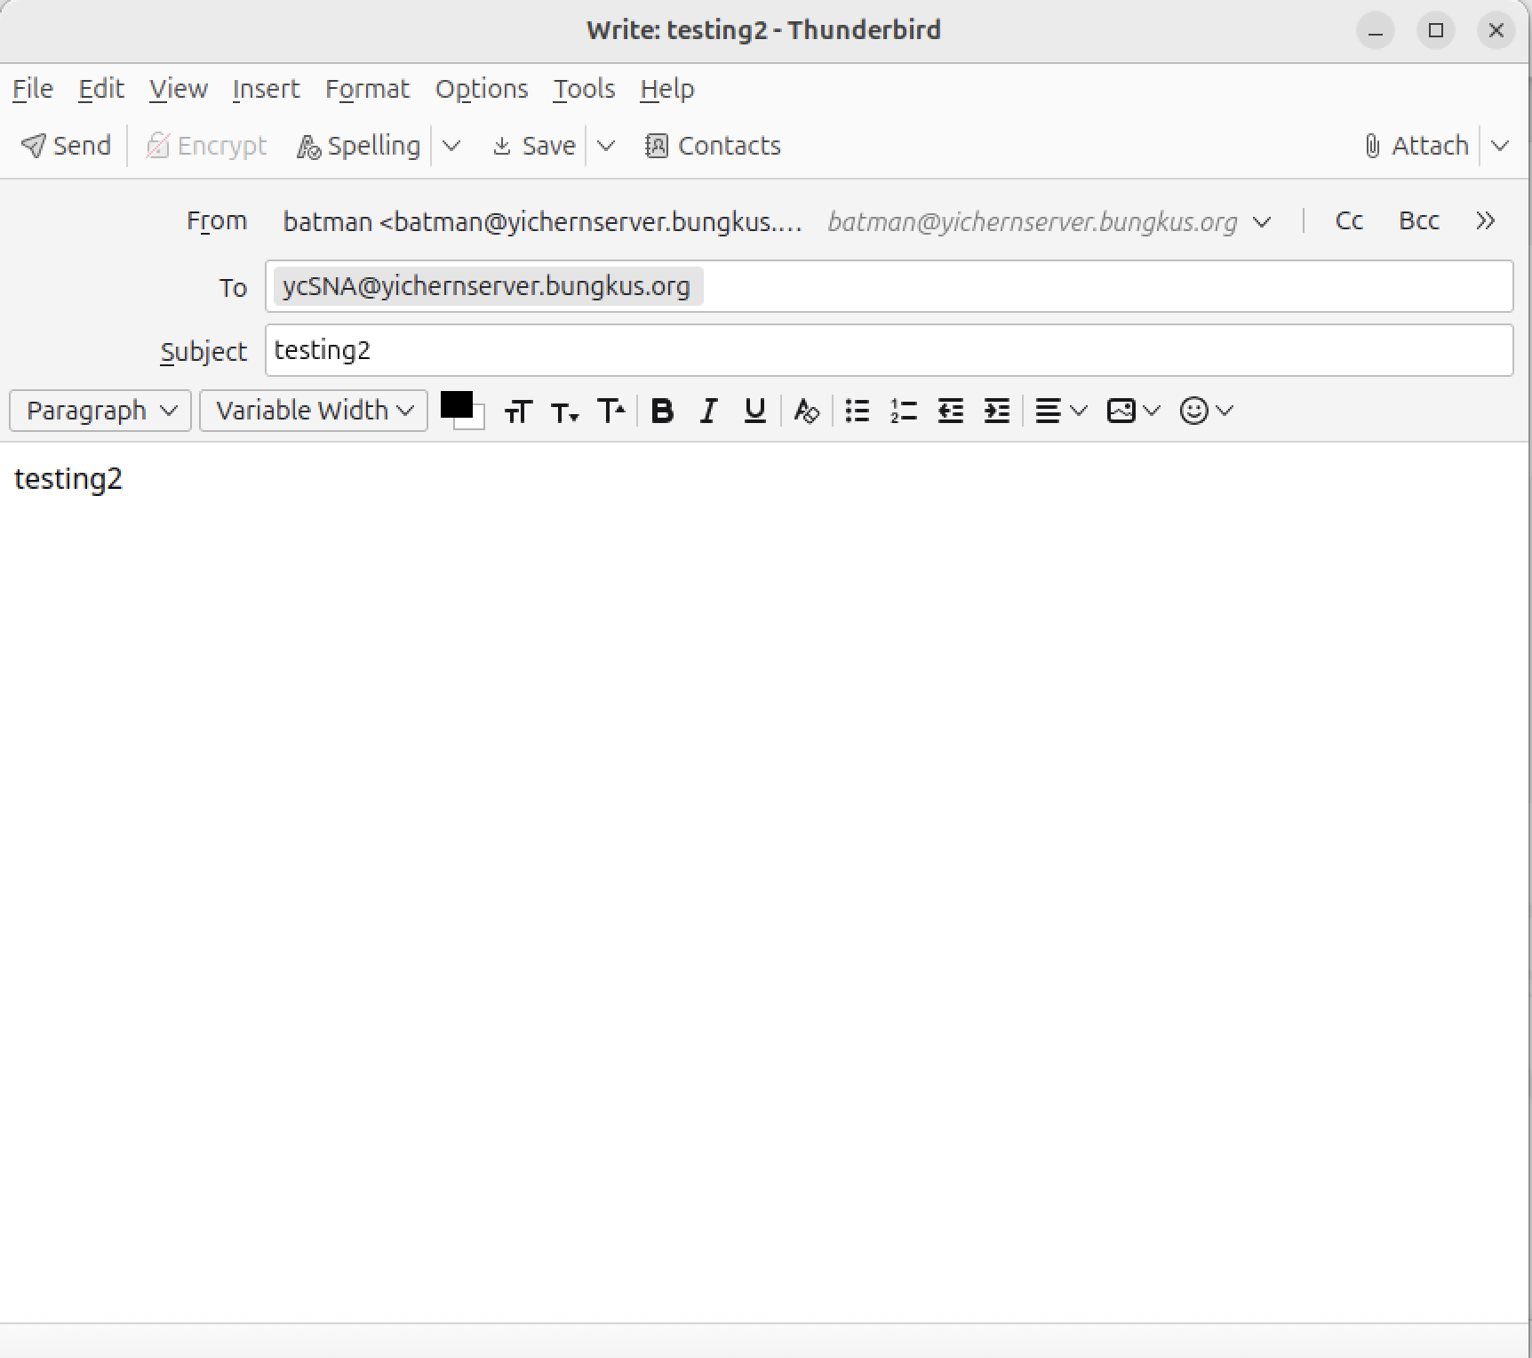
* It shows successful since we can see it in our inbox.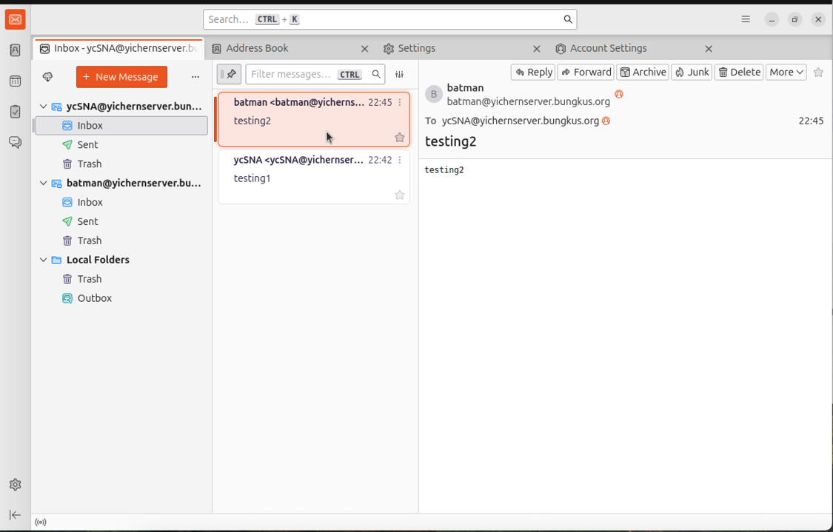

# 8.0 Troubleshooting

1. Certificate not found

- While checking whether Postfix on port 587 supports STARTTLS using following command, it shows that there are no client certificates

* openssl s_client -starttls smtp -connect yichernserver.bungkus.org:587

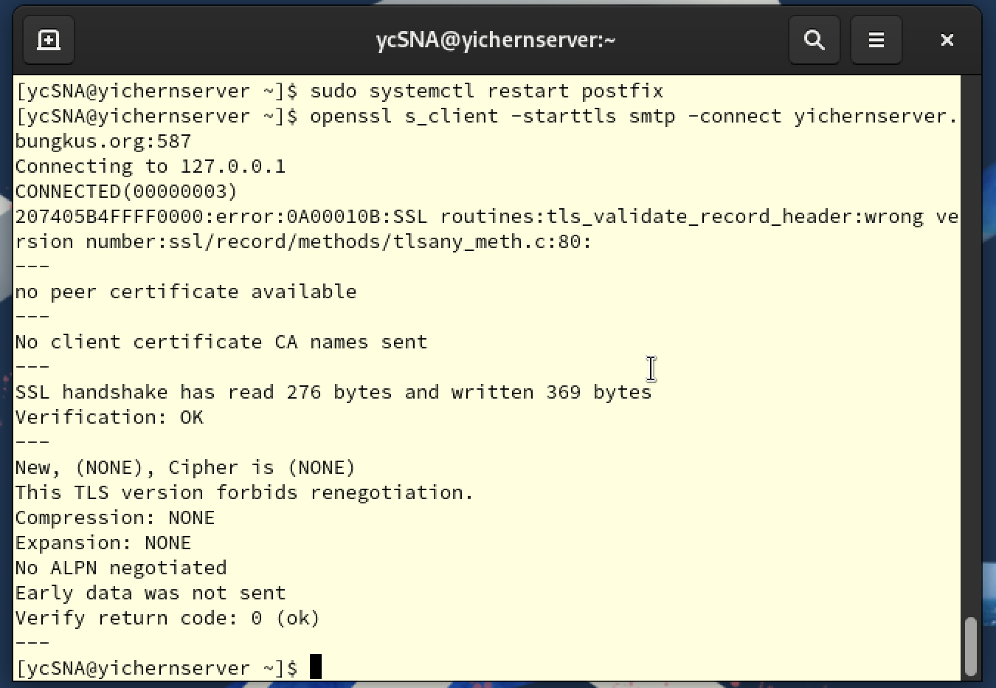

- It means that our configuration have problems, Postfix can’t connect to port 587 (STARTTLS). So we need to go back to the master config file of Postfix to complete the configuration.

- In postfix master config file (sudo nano /etc/postfix/master.cf) make sure that all these lines uncommented to let Postfix submission service on port 587 is speaking to TLS properly





2. Can’t receive mail after sending

- After sending an email to myself, email isn’t received in our inbox.

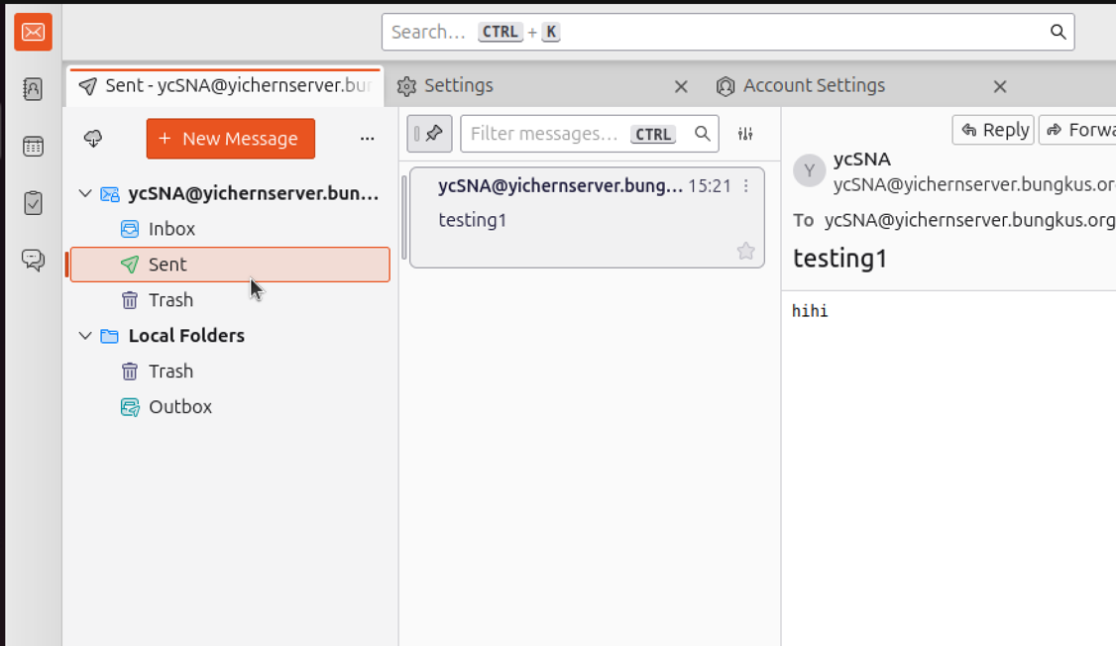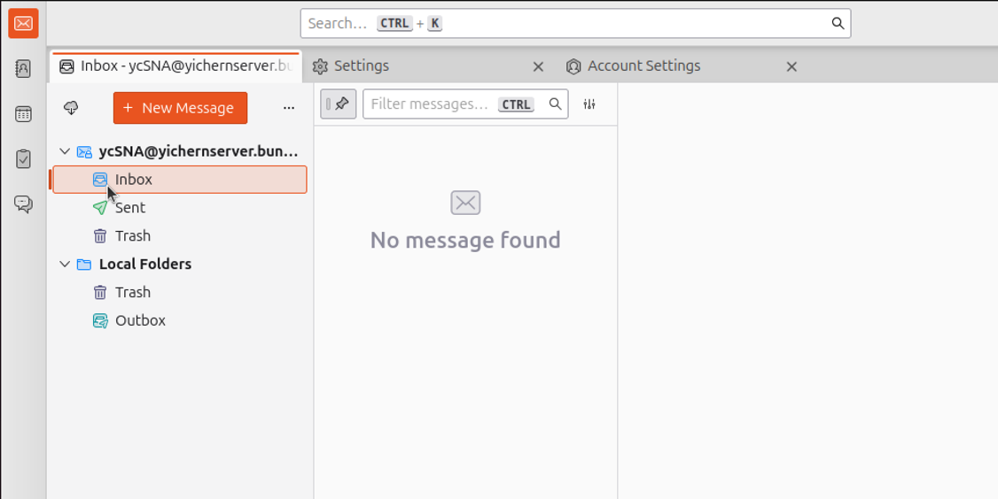

-The possible reason of occurring this error is Postfix are delivering to location that Dovecot is not reading.

- So we need to check both Postfix and Dovecot using the same location (maildir:~/Maildir)

- In Postfix (sudo nano /etc/postfix/main.cf)



- In Dovecot (sudo nano /etc/dovecot/conf.d/10-mail.conf)



3. Error occur while sending mail.

- It shows that the “TLS not available dur to local problem” while we try to send a mail.

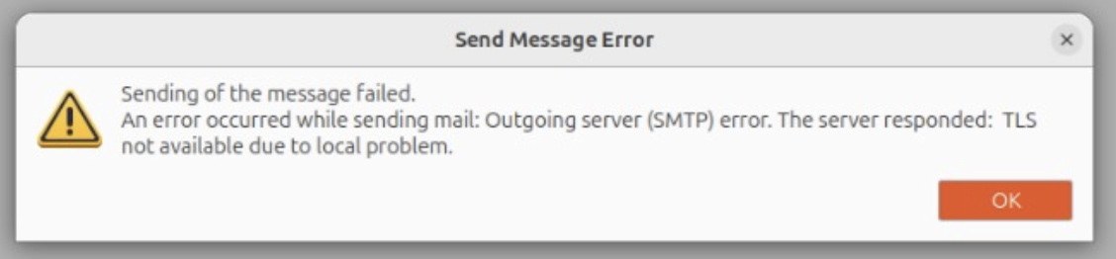

- This means that we have a misconfiguration or missing requirement in our Postfix TLS setup.

- First, we check whether Postfix locate the certificate and key in the path that we created.



- Next, we check the key has a correct permission (it supposed to be chmod 600)



- Last, check whether TLS enabled and ensure there are no confliction.



- Then, we restart the Postfix.



# 9.0 Certificates of Attendance

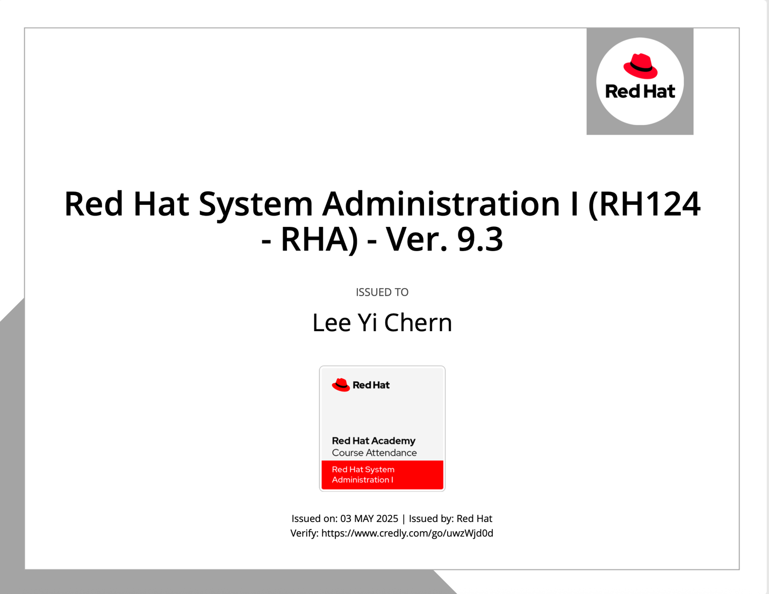

# 10.0 Conclusion

In conclusion, this assignment has clear guidance for creating an email service system by using Postfix as the Mail Transfer Agent (MTA), Dovecot as the Mail Delivery Agent (MDA), and Mozilla Thunderbird as the client interface. Not only that, this assignment also configured SSL/TLS encryption to ensure security while sending and receiving email, using a self-signed certificate that is only used internally. This project demonstrated the integration of essential Linux-based email services through configuring submission ports, authentication methods, firewall rules, and so on. Additionally, this project highlighted the importance of proper network configuration, service collaboration, and secure authentication in real-world system administration.

# 11.0 References

*Chapter 2. Deploying and configuring a Postfix SMTP server | Red Hat Product Documentation*. (n.d.). https://docs.redhat.com/en/documentation/red_hat_enterprise_linux/9/html/deploying_mail_servers/assembly_mail-transport-agent_deploying-mail-servers

*Chapter 1. Configuring and maintaining a Dovecot IMAP and POP3 server | Red Hat Product Documentation*. (n.d.). https://docs.redhat.com/en/documentation/red_hat_enterprise_linux/9/html/deploying_mail_servers/configuring-and-maintaining-a-dovecot-imap-and-pop3-server_deploying-mail-servers#configuring-and-maintaining-a-dovecot-imap-and-pop3-server_deploying-mail-servers

SoulSpeaker. (2024, October 6). *How to send mail using postfix| Postfix configuration on linux| send mail with gmailusing postfix* [Video]. YouTube. <https://www.youtube.com/watch?v=cAMdDJOD3YU>